

Assignment Cover Sheet
Candidate Number | 032678
Module Code | BEMM466
Module Name | Business Project
Assignment Title | Business Project

Within the Business School we support the responsible and ethical use of GenAI tools, and we seek to develop your ability to use these tools to help you study and learn. An important part of this process is being transparent about how you have used GenAI tools during the preparation of your assignments.
The below declaration is intended to guide transparency in the use of GenAI tools, and to assist you in ensuring appropriate referencing of those tools within your work.

The following GenAI tools have been used in the production of this work:
[please specify] ………………………………………..
☐ I have used GenAI tools for brainstorming ideas.
☒ I have used GenAI tools to assist with research or gathering information.
☒ I have used GenAI tools to help me understand key theories and concepts.
☒ I have used GenAI tools to identify trends and themes as part of my data analysis.
☐ I have used GenAI tools to suggest a plan or structure of my assessment.
☒ I have used AI tools to give me feedback on a draft.
☐ I have used GenAI tool to generate images, figures or diagrams.
☒ I have used AI tools to proofread and correct grammar or spelling errors.
☐ I have used AI tools to generate citations or references.
☒ Other [please specify] helping with coding

☒ I declare that I have referenced use of GenAI tools and outputs within my assessment in line with the University referencing guidelines.

Candidate Number: 032678

Customer Segmentation and Service Recovery in Brazilian E-Commerce: A Hybrid Clustering and Topic Modelling Approach Using Olist Data

List of Contents
Executive Summary 5
Introduction 9
Industry Context 9
Problem Statement 9
Justification for This Project 10
Research Question 11
Objectives 11
Literature Reviews 12
E-Commerce 12
Importance of E-Commerce 12
Key Challenges 13
Role of Marketing in E-commerce 13
Latin American E-commerce and the Case of Olist 13
Applications of Marketing in E-commerce 15
Implications of Marketing for E-commerce 15
Customer Segmentation in E-Commerce 17
Customer Segmentation 17
Segmentation for Personalization 17
Clustering Methods and Validation for Segmentation 18
K-Means Clustering 18
Comparison with Other Methods 19
Cluster Validation Techniques 20
Topic Modeling for Customer Insights 21
Strengths and Limitations of Transformer-Based Approaches 21
Evaluation Metrics and Managerial Relevance 21
Gaining Customer Insights 22
Case Studies and Managerial Implications 22
Methodology 24
Overview of the analytical framework 24
Research Design 24
Data Source and Contextual Boundaries 25
Data Preparation 26
Data Cleaning 26
Clustering and Validation 27
Cluster Selection 28
Topic Modelling with BERTopic 28
Ethical Considerations 29
Results 30
Descriptive Analysis 30
Elbow Method 31
Clustering Results 32
ANOVA Results 33
Tukey’s Post-Hoc Results 34
Selected Cluster for Deeper Analysis 37
Customer Review Analysis (BERTopic) 37
Keyword Diversity 40
Semantic Coherence 41
Discussion 42
Cluster Profiles and Interpretation 42
Managerial Implications 44
Conclusion 47
Reference lists 49
Appendices 55
Appendix A: Onedrive Directory Link 55
Appendix B: GitHub Repository Link 55
Appendix C: Coding Explanation 55
Appendix D: Business Proposal 63

Table of Figures
Figure 1: Project Analytical Framework 24
Figure 2: Olist Data Schema (Olist & André, 2018) 25
Figure 3: The Most Common Category of Products 30
Figure 4: Top 10 of Customers’ city in Brazil 30
Figure 5: Elbow Method for Clustering 31
Figure 6: Cluster Analysis Results 32
Figure 7: ANOVA test Results 33
Figure 8: Tukey's HSD result for total_spend_winsor variable 34
Figure 9:Tukey's HSD result for avg_order__value_winsor variable 34
Figure 10: Tukey's HSD result for avg_payment_installments variable 35
Figure 11: Tukey's HSD result for avg_review_score variable 35
Figure 12: Tukey's HSD result for category_diversity variable 36
Figure 13: Tukey's HSD result for recency_days variable 36
Figure 14: Word Cloud of Topic 1 37
Figure 15: Word Cloud of Topic 2 37
Figure 16: Word Cloud of Topic 3 38
Figure 17: Word Cloud of Topic 4 38
Figure 18: Word Cloud of Topic 5 38
Figure 19: Word Cloud of Topic 6 39
Figure 20: Word Cloud of Topic 7 39
Figure 21: Word Cloud of Topic 8 39
Figure 22:Word Cloud of Topic 9 40

Title: Customer Segmentation and Service Recovery in Brazilian E-Commerce: A Hybrid Clustering and Topic Modelling Approach Using Olist Data

Executive Summary
E-commerce is one of the main drivers of the modern economy in Latin America, the phenomenon has grown particularly robust (Da Veiga et al., 2024). Platforms like Olist have enabled thousands of small firms to sell online. But such scale also creates challenges. Consumers may experience delivery lags, unreliable vendors, and inconsistent service levels. Furthermore, negative experiences often amplify through online reviews (Gomes et al., 2023; Varga & Albuquerque, 2019). The present study is focused on how Olist could achieve a more in-depth understanding of its consumers. It will examine the application of behavioural segmentation, using reviews to provide an analysis that captures not just the what but the how of customer behaviour.
The fundamental problem is the disconnect between customer behaviour and sentiment. Segmentation focuses on grouping buyers based on spend, frequency, or product mix but cannot account for satisfaction or dissatisfaction (Klaus & Maklan, 2013; Suh, 2025). For Olist, the issue is risky because unhappy customers are more vocal. Therefore, the research question is how can segmentation and review analysis be combined to generate insights that drive personalized marketing and service recovery?
This study had two objectives. The first objective was to segment the Olist's customers into homogeneous groups based on behavioural and transactional features, provide a baseline understanding of heterogeneity and highlight potentially risky or with retention opportunity clusters. The second objective was to employ topic modelling over reviews in one of the identified clusters and define topics and pain points which cause dissatisfaction. The objectives together aimed at bridging the gap between quantitative and qualitative studies by firstly clustering users based on their behaviour and secondly analysing user sentiment with the topics found in their reviews. The combined objectives aimed at providing not only academic understanding of the interplay between user behaviour and experience, but also recommendations to the studied platforms, like Olist, which operate in competitive and trust based markets.
The two-stage analysis design is as follows. Stage one employed K-Means clustering with features of recency, frequency, spend, instalments, category diversity, and review scores (Wang et al., 2024). K-Means is a popular clustering method among e-commerce research for its good balance of accessibility and interpretability (Gomes & Meisen, 2023;
Sinaga & Yang, 2020). The data was cleaned with imputation for missing values, winsorisation for outlier effects, and feature scaling for data robustness (Emmanuel, 2021; Zhou et al., 2024; Khan et al., 2024). The Elbow Method was then used to identify an ideal number of clusters, with five found to be a good balance for solution clarity (Tabianan et al., 2022), and ANOVA with Tukey’s tests were performed to ensure statistically significant differences between clusters (Kevrekidis et al., 2017; Pedro et al., 2024).
Stage two then analysed the reviews of the cluster with the lowest satisfaction. A transformer-based topic modelling method, BERTopic, was used to extract themes from the review comments (An et al., 2023; Grootendorst, 2022). This technique was used for its strong performance on shorter texts like reviews, offering better coherence and diversity than earlier methods (Muriël et al., 2022; Dieng et al., 2020).
The segmentation resulted in 5 separate clusters. Cluster 0 were high value, instalment-driven customers. Cluster 1 was the largest group with low spend, high satisfaction and recent activity. Cluster 2 were variety-seekers with above-average spend, but mixed satisfaction levels. Cluster 3 contained more than 12,000 moderate spenders with very low review scores (≈1.7). Cluster 4 were inactive, low-spend customers. These clusters had clearly different behaviour patterns and satisfaction levels.
The most important result was the paradox between Clusters 1 and 3. Cluster 1 spent little but were satisfied and engaged. Cluster 3 spent much but were dissatisfied. This finding challenges the assumption that financial value drives loyalty. Expectation–Confirmation Theory (Bhattacherjee, 2001) explains Cluster 1, as low expectations were surpassed. SERVQUAL (Parasuraman et al., 1988) and Justice Theory (Tax et al., 1998) explain Cluster 3's focus on reliability and fairness issues. This paradox shows that loyalty is more influenced by service quality than by spending.
The review analysis confirmed these suspicions. Ten product-related dissatisfaction themes were identified, including damaged products, wrong variants, delayed shipments, order cancellations, missing items, defective electronics, low quality, and distrust of sellers. Many buyers also expressed complaints on a formal level asking for refunds or replacements. The results are in line with Xu et al. (2022), who point out weak logistics and order management processes at Olist. The analysis corroborated that dissatisfaction with the marketplace Olist is not limited to delivery but also concerns product quality and after-sales support.

This research has both theoretical and applied contributions. On the theoretical front, this study extends the segmentation research by integrating behavioural clustering with experiential analysis. The hybrid approach provides a more holistic understanding of customer heterogeneity (Gomes & Meisen, 2023). In addition, the study validates the underlying theories related to service quality by demonstrating that both SERVQUAL and Justice Theory are applicable in the digital context. It employs Expectation–Confirmation Theory to explain the Satisfaction behavior observed in the low-value cluster and advances the operationalisation of Service-Dominant Logic by treating reviews as value co-creation contributions (Vargo & Lusch, 2003). The findings, particularly the paradoxes in spend and satisfaction, challenge conventional assumptions in loyalty research (Kevrekidis et al., 2017).
Managerial implications are clear. Cluster 0 customers should be retained through loyalty tiers, premium after-sales support, and fraud detection (Kaur, 2024). Cluster 1 should be nurtured with referral programmes, gamification, and onboarding journeys (Kumar & Reinartz, 2016). Cluster 2 need category audits, curated bundles, and transparency dashboards to smooth inconsistent experiences (Mor et al., 2024). Cluster 3 requires urgent recovery through refunds, guaranteed delivery, loyalty credits, and transparent complaint handling, backed by reforms such as enforceable logistics contracts and verified sellers (Xu et al., 2022; Lim et al., 2025; Smith & Bolton, 1998). Cluster 4 can be reactivated through multi-channel campaigns using email, WhatsApp, and in-app notifications (Santoso & Sudarmiatin, 2024). These actions show that improving customer experience requires both marketing innovation and operational reform.
The project also recognises ethical considerations and limitations. The dataset is anonymised and shared under a CC BY-NC-SA 4.0 licence, ensuring responsible reuse (Labastida & Margoni, 2019). Still, the timeframe (2016–2018) predates the post-COVID surge in e-commerce, limiting relevance to current markets (Xu et al., 2022). Reviews were voluntary and translated from Portuguese, introducing possible bias. Methodologically, K-Means makes strong assumptions about cluster shapes (Khan et al., 2024), and topic modelling results varied in coherence (Dieng et al., 2020). These factors mean the findings are best read as methodological insights rather than direct predictions.

Future research can build on this by applying the framework to newer data or across markets to test its universality (Valdivino et al., 2025). Exploring alternative clustering methods such as DBSCAN could capture more complex behaviour (An et al., 2023). Multilingual transformer models would improve review analysis in non-English contexts (Muriël et al., 2022). Finally, experimental designs such as A/B testing recovery strategies would help validate whether interventions truly build loyalty (Lim et al., 2025).
In conclusion, this project shows that understanding customers requires both behavioural and experiential analysis. By combining clustering with topic modelling, it reveals paradoxes that question assumptions about loyalty, while providing Olist with concrete strategies to reduce churn and strengthen trust. The broader contribution is a framework that not only supports academic debate but also equips managers with evidence-based actions for competing in the fast-changing digital economy.

Introduction
This dissertation explores the challenges of customer segmentation and service recovery within the fast-growing e-commerce sector, focusing on Brazil’s Olist marketplace. The project takes a dissertation-style format, combining quantitative clustering with qualitative topic modelling to uncover both who the customers are and why they behave as they do. By integrating these two analytical perspectives, the study addresses gaps in understanding customer behaviour and dissatisfaction in digital marketplaces.

Industry Context
E-commerce in Latin America has grown rapidly in recent years, becoming one of the most dynamic markets globally. Brazil, the region’s largest economy, accounts for more than 30% of all e-commerce activity in Latin America (Da Veiga et al., 2024). Platforms such as Olist have played a crucial role in enabling small and medium-sized businesses to sell online, creating a vibrant but highly competitive marketplace. However, the very scale and diversity of e-commerce creates new risks of service failures. Studies show that logistics delays, unreliable sellers, and inconsistent customer experiences are among the most pressing challenges in the region (Gomes et al., 2023). These issues make customer satisfaction fragile, with negative experiences often amplified through online reviews and social media visibility.

Problem Statement
The main gap in knowledge is between customer behaviour and customer sentiment. Segmentation methods enable the platform to sort customers into groups and clusters based on various criteria such as spending, frequency or product choice. However, these groupings might not account for or reflect on why some customers are satisfied or dissatisfied with their experience. The lack of customer sentiment understanding and information is particularly critical in Brazil, where the consumers are vocal and powerful. It has been found that single negative review can significantly decrease trust and purchase intention, especially in online settings where the consumers lack direct experience with the product (Varga & Albuquerque, 2019).

For this reason, the research is designed to be beneficial both for Olist’s management, by offering information that can guide improvement of operating processes and decrease churn on the platform, and to Olist’s sellers, for whom the marketplace represents one of the most important, if not the most important channel to reach their customers and make profit. By including both management and sellers’ perspective, the study underlines the connection between successful segmentation, service recovery and strengthening of trust, retention and long-term competitiveness.

Justification for This Project
The dissertation topic is both relevant and timely. First, it responds to a lack of conceptual integration between existing customer segmentation approaches (behavioral models) and experiential dissatisfaction that theses approaches tend to ignore (Klaus & Maklan, 2013). Second, when using clustering, we would ordinarily assume that the method would segment customers by their behaviour. However, what clustering does on the technical level does not always match what it achieves when it comes to understanding customer behaviour. For instance, recent studies have shown in the digital commerce context that RFM-based approaches “fail to capture the full complexity of modern customer interactions”, and focusing on purchases only risks missing out on the dissatisfaction signals contained in reviews (Suh, 2025).
This is more than a theoretical issue for Olist: Xu et al. (2022), studying operational data from Olist itself, see signs of limited customer loyalty, order confirmation process inefficiencies, and periodic delivery delays, especially during peak demand. Such issues suggest operational, structural problems, yet Xu et al.’s study remains quite descriptive in nature, focusing on operations. The authors themselves remark that more analytical analysis could be beneficial, particularly when aligning behavioural patterns with review-based signs of dissatisfaction.
This dissertation therefore extends prior research by combining behavioural clustering with topic modelling of customer reviews, offering a two-dimensional framework that identifies not only who the dissatisfied customers are but also why they are dissatisfied. The contribution lies not just in technical innovation but in bridging the conceptual divide between behavioural segmentation and experiential dissatisfaction. For Olist and similar platforms, the outcome is actionable strategies to reduce churn, recover trust, and strengthen competitiveness in Latin America’s fast-growing e-commerce sector.

Research Question
The increasing demand for online shopping has resulted in a higher requirement for e-commerce businesses to not only segment their consumers according to their shopping behavior, but also to determine the reasons behind the customer's satisfaction or dissatisfaction. The primary goal of the project is to deliver actionable and valuable knowledge for personalized marketing and service recovery by combining the quantitative and qualitative consumer segmentation approaches. Specifically, the research question is how to combine customer segmentation and their review analysis to detect actionable insights for personalized marketing and service recovery in e-commerce.

Objectives
Objective 1 – using behavioural and transactional features in order to group customers into clusters. This will create a base understanding of heterogeneity in the customer base, as well as specific clusters that may require retention action.
Objective 2 - using the topics modelling approach in order to examine the reviews of a chosen cluster, and find pain points or themes that drive dissatisfaction. This will give a two-dimensional perspective on the customers, both from transactional profile as well as experience perception.
The two objectives both come from understanding a common theme of using quantitative segmentation data, and more unstructured data with qualitative insights from sentiment analysis. The thesis itself, therefore, will have dual deliverables of understanding customer behaviour/experience interaction both on a research perspective as well as actionable steps for businesses like Olist, which function in highly competitive and trust-vulnerable spaces.
The boundaries of this dissertation are the Olist dataset, which contains transaction data and customer reviews. With these boundaries, this research can consider customers’ purchasing behaviors and their experience-based evaluations. This consideration can provide a more comprehensive and deep understanding of the determinants of satisfaction and dissatisfaction in e-commerce settings. This study’s original contribution is the joint use of clustering and topic modelling. This contribution can recognize who the customers are and why some specific customer groups express dissatisfaction. It can overcome the drawback of the existing segmentation methods that use only purchase data and provide more practical and actionable implications to the managers and sellers of the online platforms. The organization of this dissertation is as follows. After this introduction chapter, this dissertation provides the background and overviews of the main debates on segmentation, marketing, and service recovery. Then, the methodological framework and procedure of this dissertation are explained and applied to the Olist dataset. After that, the results are presented and described. This dissertation then moves to the interpretation of the research results and how they can be linked to the existing theory and practice. Finally, the contributions, the limitations, and the future research are discussed to conclude the dissertation.

Literature Reviews

E-Commerce

Importance of E-Commerce
E-commerce is a significant part of the world economy with global online retail sales having a multitrillion-dollar value in recent years (Dujardin, 2025). It is considered one of the most crucial state economy growth factors (Soava et al., 2022). In the environment that occurred due to the digital acceleration after the COVID-19 pandemic, e-commerce has substantially changed the way people consume and the corresponding expectations that form a new digital consumer profile (Soava et al., 2022). As e-commerce could not only satisfy these needs for one or several consumers but at a significantly large scale, in the new digital economy, it serves as a technological and distribution instrument (Soava et al., 2022). E-commerce as a solution forces a firm to technologically innovate to stay competitive, significantly changing the way they sell their products and services and leading to overall competition for innovative promotion means. Although most academic research points to digitalization as an overall good for the market, some point to the possible increase in the digital divide by pushing aside some customers without access (Cai, 2025). This calls attention to a specific market duality: on the one hand, e-commerce is considered a growth factor and stimulator of innovation, and on the other hand, its effect on the economy may be negative for some consumers. For business, this may mean that an enterprise cannot take for granted its customers’ “digital readiness” and has to be inclusive in its strategies to be competitive.

Key Challenges
While e-commerce is a fast-growing industry, there are numerous challenges that are present in the industry. One major challenge is Intense Competition and Customer Expectations: The low barriers to entry and global nature of online retail lead to intense competition. Customers can easily compare different options online, and as a result e-commerce companies face pressure on price, product quality, and shipping speed. Price competition (e.g. discounts) may be required to attract price-sensitive customers in markets like apparel (Gupta et al., 2023). Moreover, customers have come to expect fast shipping and excellent customer service, making logistics and service delivery excellence major challenges (Gupta et al., 2023). Some view competing on price and speed as essential to meeting customer expectations, while others warn this leads to a “race to the bottom” where profitability is eroded and labor practices in logistics and delivery networks are exploited (Kim et al., 2021). The issue thus exemplifies a tension between short-term competitiveness and long-term sustainability.

Role of Marketing in E-commerce
In today’s saturated digital world, attracting and retaining customers is a process. To succeed in the online marketplace, marketers must have access to viable marketing channels that help them direct traffic, stand out from the competition, and secure ongoing loyalty (Ali et al., 2025). For this reason, e-commerce calls for data-driven, customer-centric approaches, while the broad strokes of traditional mass marketing fall flat in the face of modern online customers’ expectations. (Gomes & Meisen, 2023). Identifying customer needs and segmenting diverse, multi-dimensional audiences into meaningful, target groups sets the groundwork for more relevant initiatives than generic one-size-fits-all campaigns (Gomes & Meisen, 2023). In this way, it recasts marketing not simply as a tactical tool for promotion, but as a strategic discipline that empowers firms to provide customized experiences and cultivate deeper, more enduring relationships with their customers.

Latin American E-commerce and the Case of Olist
Online shopping in Latin America has grown quickly but continues to have significant structural limitations when compared to more established markets. For instance, studies have identified that adoption of e-commerce in the region is associated not only with digital readiness but also with varying levels of trust, social media use, and infrastructural capacity (Valdivino et al., 2025). Empirical findings indicate that trust in the vendors themselves has sometimes been a stronger predictor of e-commerce sales in Latin American countries than even prices (Correa et al., 2021). However, other scholars have pointed out that Latin American e-commerce remains relatively “fragmented” with respect to the variety of platforms and delivery channels and underdeveloped compared to other countries, with limitations including inadequate logistics capacity, insufficient institutional support, and lack of digital payment systems (Machado Parente et al., 2023). This translates into a greater degree of uncertainty and risk for the online shopper relative to those in the North America or Europe.
Olist can be understood as one microcosm of these broader tensions. On one hand, the platform has democratized online retailing by connecting thousands of micro-merchants to customers across Brazil. On the other hand, Olist suffers from many of the quality and performance issues that are all too common in the region’s e-commerce scene. Previous studies have shown that fragmentation in logistics networks, for instance, has resulted in late deliveries or outright cancellations of orders (Xu et al., 2022). At the same time, Olist contains a number of unverified sellers which, while a positive development in terms of competition, has also led to questions about product authenticity and overall trust. A common thread in customer reviews that Olist products have experienced difficulty with slow delivery, damage during transport, and poor communication from the platform during both ordering and shipping. While much of the prior marketing literature on Latin America has focused on the issue of adoption and digital inclusion (Valdivino et al., 2025), relatively less attention has been paid to the issue of how to react to a “switched on” customer who has negative experiences with an e-commerce platform. This can be seen as an important omission, both in the academic literature and in the firm’s own managerial practices: prior literature explains how and why e-commerce adoption is uneven across the region, but tends to neglect how to react to customers who adopt, but then have a poor experience with platform usage.
In order to bridge this gap, it is essential to compare the Latin American case with the larger scholarly and managerial debate on marketing in e-commerce. In order to contextualize Olist’s situation, this section of the paper first surveys the body of literature on how marketing itself has been used successfully or otherwise in e-commerce firms worldwide. This background, in turn, sets the stage for the analytical approach that this study uses later on.

Applications of Marketing in E-commerce
Expanding on this role, the extant literature also emphasizes the variety of marketing applications in the e-commerce context. Personalization is the most prevalent practice, with platforms like Amazon and Alibaba using recommendation systems and targeted advertising to increase conversion and loyalty (Hassan et al., 2025). Customer Relationship Management (CRM) and loyalty programs are also common, aiming to retain long-term relationships and drive repeat purchasing (Rane et al., 2023). In developing countries where e-commerce growth is limited by infrastructure deficits and fragmented logistics, digital engagement on social media platforms like WhatsApp and Instagram has shown success in building direct firm-consumer linkages (Valdivino et al., 2025). These applications suggest that marketing in e-commerce is not just a promotion tool but rather central to adoption, retention, and competitive advantage.

Implications of Marketing for E-commerce
However, these applications are not risk-free. It is also well-evidenced that marketing tools may have boomerang effects. For example, while personalization increases relevance, too much targeting has been found to activate the personalization–privacy paradox (perceived intrusiveness, diminished trust) (Bleier & Eisenbeiss, 2015). Fast delivery promises in promotional campaigns can harm brand credibility when they fail to be honored by the operational network (e.g., Olist and other Latin America platforms), (Xu et al., 2023). Homogeneous campaigns that fail to consider customer heterogeneity squander resources, while ignoring negative reviews only hastens churn.
Theoretical perspectives on these tensions are also helpful. Expectation–Confirmation Theory (Bhattacherjee, 2001) accounts for the effects of unmet expectations (driven by marketing communications) on the subsequent performance of the service, but is criticized for not accounting for the emotionality and trust-based dimensions of satisfaction. SERVQUAL (Parasuraman et al., 1988) has been used to show that reliability and assurance elements are the most important in the formation of perceptions of online service quality, but the model has also been criticized in digital contexts for the intangibility of its scope. The Service Recovery Paradox (Smith & Bolton, 1998) has been proposed to demonstrate the impact of a firm's failure recovery performance on the formation of future loyalty, but its existence has been demonstrated to be restricted to small, non-recurrent problems (Ren et al., 2010).

Broader frameworks allow for further extensions. Service-Dominant Logic (S-D Logic) (Vargo & Lusch, 2004) can reframe e-commerce from a lens of value co-creation among platforms, sellers, and customers. Customer reviews are active voice thus, value creation rather than mere information (Aouad & Spinuzzi, 2017). Reviews shape evaluations of service quality and trust, which are central concepts in S-D Logic (Abreu et al., 2020). However, S-D Logic is often critiqued as too abstract, with analytical tools like segmentation and topic modeling allowing customer voice to be distilled into actionable intelligence. Justice Theory (Tax et al., 1998) can complement this by foregrounding the influence of distributive (fair outcomes), procedural (fair processes), and interactional (fair communication) justice perceptions on customer responses to dissatisfaction and recovery. On Olist’s reviews, customers express grievances that precisely target these dimensions of justice, such as delayed deliveries, unverified sellers, inadequate complaint handling, etc. However, this theory is also limited as it is focused on recovery, not initial adoption.
These implications demonstrate that e-commerce marketing effectiveness depends on specific conditions and contexts that cannot be detached from ongoing operational considerations. To the academic community, they point to a conceptual void: theories that are instructive to explain relevant phenomena (ECT, SERVQUAL, SRP, S-D Logic, Justice Theory) remain silent on the coupling between who customers are and why they end up satisfied or dissatisfied. To the business community, they signal to managers that marketing promises cannot be decoupled from the delivery of service, justice, and voice. It directly justifies the present study in a straightforward manner: by integrating customer segmentation (what) with topic modeling (why) to identify a more complete, data-driven view of who customers are and why they are satisfied/dissatisfied, we may be able to build a more actionable foundation for designing marketing strategies that better accentuate successes and reduce failures.

Customer Segmentation in E-Commerce

Customer Segmentation
Customer segmentation is the strategy of segregating a customer base into groups of customers (segments) so that customers in the same segments share similar characteristics or behaviors (Gomes & Meisen, 2023). The customer segmentation process is typically a data-driven, unsupervised learning process: firms collect and process customer data and deploy clustering algorithms to identify and describe similar user behavior and cluster customers based on measured similarity (Gomes & Meisen, 2023). Segmentation can typically be performed by demographics, web browsing history and activities, purchases, and value (RFM: Recency, Frequency, Monetary value).
Benefits of customer segmentation implementation in e-commerce. E-commerce companies, that have implemented customer segmentation experience many advantages, such as the ability to further understand their customers’ needs, behaviors and make marketing both effective and efficient. Customization and personalization are made to improve value propositions, messaging and promotions that are specifically tailored to each segment, which also greatly increases relevance. Academic studies point out that either marketers or automated systems can making personalization for them to generate marketing plan effectively according to customer segmentation (Gomes & Meisen, 2023). Another benefit is that it serves as a foundational step toward personalization and, ultimately, customer satisfaction. If a customer receives a promotion that is relevant to their needs and interests, they are more likely to engage with that content and convert. As a result, the personalization that segmentation supports leads to higher customer satisfaction over time and increased loyalty. It is precisely the principles of analytical CRM that uses customer segmentation to more effectively focus on serving the most profitable group of customers and get maximum customer lifetime value (Kevrekidis et al., 2017).

Segmentation for Personalization
This leads us to the primary purpose of good segmentation: Enabling one-to-one marketing at scale. If you’ve segmented your customer base properly, you should have a set of distinct customer clusters that can each be targeted with segment-specific strategies. This is the fundamental objective of e-commerce personalization, as consumers have come to expect relevant product recommendations, targeted advertising, and customized promotions as a standard part of their online shopping experience. Segmentation, for example, can be the foundation of personalization at various levels. This could include everything from personalized product recommendations for different customer segments (high-end shoppers vs. deal-seekers) to personalized email marketing with content and offers tailored to the interests and preferences of each segment. This is a widely studied field with a proven track record, and studies repeatedly confirm the positive impact of personalization. These include higher conversion rates, enhanced customer experience, and increased customer loyalty (Gomes & Meisen, 2023). In that sense, customer segmentation is the foundation that enables one-to-one marketing. E-commerce personalization is about delivering the right offer to the right customer at the right time. Segmentation provides the framework for this.

Clustering Methods and Validation for Segmentation

K-Means Clustering
K-means clustering is likely the most commonly used customer segmentation technique for e-commerce in recent years (Gomes & Meisen, 2023). In essence, k-means algorithm initializes k cluster centroids and iteratively repositions them in the k-dimensional data space in a way that reduces the distance of points to their closest centroid, with Euclidean distance being the standard (Gomes & Meisen, 2023). This method has found broad adoption for a number of reasons: its simplicity – it is conceptually easy to understand and technically simple to implement; its scalability – the most advanced state-of-the-art methods are unable to match its ability to work with extremely large datasets, a must-have given the size of platforms such as Olist, which in a single year has millions of transactions from millions of users; and its interpretability – the final output is easy to interpret by stakeholders and experts alike as k-means produces cluster centroids, points that act as a representative profile for a cluster.
These desirable qualities have tradeoffs. First, the simplicity of k-means is achieved by design as the algorithm explicitly enforces a structure of k roughly spherical and similarly sized clusters. This need not describe the full heterogeneity of customer behavior, with potentially important subgroups such as niche customers who only buy from a specific product category or high-value customers who buy rarely but make very large purchases missed. Second, because k needs to be defined a priori, there is an unavoidable element of subjectivity, and the resulting cluster centroids can only approximate a real-world group with such simple structure. Third, k-means is sensitive to outliers, so variables often need to be winsorized and rescaled (normalized) to have a similar impact. In all, these considerations lead to a suspicion that the full heterogeneity of e-commerce may be missed with this approach, necessitating external validation methods.

Comparison with Other Methods
Alternative algorithms can overcome some of these limitations. Density-based clustering methods (e.g. DBSCAN or HDBSCAN) can identify clusters of arbitrary shape and naturally detect outliers as noise (An et al., 2023). This could be appealing when trying to find subgroups of customers with very specific (non-mainstream) and possibly more erratic purchasing behavior. However, these methods can require careful parameter tuning and are not as effective with high-dimensional data (unless the dimensionality is reduced first). Hierarchical clustering, which does not require specifying k in advance and can identify nested groupings, has been successfully applied in segmentation studies (Gomes & Meisen, 2023). While it could be advantageous in its ability to uncover a hierarchy of customer types (e.g., occasional buyers vs. inactive), it is computationally expensive, making it less suitable for large-scale industry data.
Furthermore, even if more advanced clustering approaches (e.g., deep learning-based clustering) are experimented with, k-means often remains in use either as a baseline method or as part of hybrid approaches, thanks to its good balance between performance and feasibility (Gomes & Meisen, 2023). This pragmatic dominance, however, could be concealing the fact that while k-means is easy to compute, its results may be easy to interpret but not as behaviorally close to real customers as some of its alternatives. In this respect, the evolution of customer segmentation might be seen as one more case of trade-offs between computational efficiency and behavioral realism. For Olist and other companies like it, this means that while k-means can be used as a reasonable first step, researchers and practitioners should be mindful of its limitations and ready to explore and validate complementary approaches.

Cluster Validation Techniques
After clustering is conducted, the quality and usefulness of the generated segments should be validated (Dibb & Simkin, 2010). Validation may be internal (checking the clustering structure) or external (evaluating clusters with ground truth or business criteria). Testing whether the clusters are significantly different on variables of managerial interest (e.g., using one-way ANOVA) is common in academic research as well as applied analyses. This can be used to ensure that clusters are meaningfully different on key metrics such as annual spending, purchase frequency, or satisfaction. If such evidence is not found, then the clusters can be mere statistical artefacts with little or no business meaning (Hong & Kim, 2011).
This is well illustrated in a case study of pharmacy customers. In this example, the researchers first identified three clusters. Then, in order to prove that they differ from one another on the factors that drive their purchasing behaviour, they ran one-way ANOVAs (Kevrekidis et al., 2017). Subsequently, they performed Tukey’s post-hoc tests to determine which clusters differ from one another on a given variable. In other words, a manager is now able to see not only that high-spending and dissatisfied customers are different from loyal and low-value ones but also that the former group is unique and the latter is distinct in their characteristics. This difference is far from superficial because a manager can now decide to target the former with specific promotions and to direct retention campaigns to the latter.
More generally, segmentation research has shown that validated clusters need to be identifiable, substantial, and actionable in order to be useful in practice (Tuma et al., 2011). For this reason, cluster analysis can be understood as a process of translating a high-volume behavioral dataset into segments that are both interpretable and actionable by managers (Reutterer & Dan, 2019). Recent empirical research also shows that pairing interpretable clustering with RFM-style validation significantly improves marketing resource allocation and aids in the prioritization of profitable or at-risk groups (Kumar, 2025). In this way, the application of ANOVA and Tukey's HSD goes beyond simple statistics: it reassures managers that the segments are both distinct and strategically relevant, allowing managers to choose five clean, interpretable segments over a more mathematically robust but less actionable solution.

Topic Modeling for Customer Insights
Topic modeling is an NLP technique that aims to identify latent topics, or thematic structures, from a large corpus of unstructured textual data, such as customer reviews. For customer reviews, the idea is to use topic modeling to automatically extract the topics that customers most commonly write about. A 'topic' can be understood as a cluster of commonly co-occurring keywords that form an underlying theme. Note that this is a form of unsupervised text classification, which means that rather than predicting into known categories, the model can infer topics directly from the words (An et al., 2023). By applying topic modeling to thousands of reviews, firms can rapidly get insights such as whether customers commonly write about delivery speed, product quality, or customer service. One advantage of these approaches is that they can help managers move beyond anecdotal impressions and base their product/market strategy on more systematic evidence.

Strengths and Limitations of Transformer-Based Approaches
Frequency-based methods, like Latent Dirichlet Allocation (LDA), have been widely used in consumer research (An et al., 2023). However, recent years have seen a shift towards transformer-based approaches, such as BERTopic. These models leverage the contextual embeddings of words, allowing for more nuanced topic representations. BERTopic, for instance, generates topics by clustering BERT embeddings, often resulting in outputs that align more closely with human interpretation. It helps to disambiguate topics such as “battery life” vs. “charging time”, which a purely frequency-based approach would likely conflate. However, this increased accuracy comes with trade-offs. Transformer-based methods are computationally intensive and can be opaque to managers. The direct output is typically a set of embeddings and clusters of keywords, rather than neatly interpretable themes. This necessitates an additional translation step to distill the machine's output into actionable themes (“delivery delays” rather than “delay, late, delivery, courier” for example). The source data itself may also be biased, as the typical customer who leaves reviews tends to be an outlier with a very negative experience (those with neutral or positive opinions tend to simply not leave reviews). Managers should therefore view topic modeling as a decision-support tool, rather than as a perfect mirror of their customer base.

Evaluation Metrics and Managerial Relevance
To make topics relevant, researchers typically validate two measures: topic coherence and topic diversity (Dieng et al., 2020). Topic coherence indicates how semantically similar the keywords in a topic are. The higher the coherence, the more intuitive sense the topic makes (e.g., battery, charge, hours, life obviously all pertain to “battery life”), which in turn, should result in greater managerial confidence in using the insight. Topic diversity, on the other hand, captures how distinct topics are from one another. The higher the topic diversity, the greater the variety of issues the model has captured without overlapping information. From a managerial standpoint, these statistics are more than just an exercise in model evaluation. High topic coherence ensures that the themes and insights generated will be easily digestible and actionable by decision makers, and high topic diversity should give managers confidence that different dimensions of the customer experience are being taken into account and not overlooked.

Gaining Customer Insights
Applied to reviews, topic modeling can reveal which product attributes customers value and which trigger dissatisfaction. For example in Joung and Kim (2023), smartphone reviews may show enthusiasm for camera quality but complaints about battery performance, highlighting where to direct product improvements. Clustering reviews by opinion can also uncover cross-selling opportunities (e.g., customers mentioning “tablet” alongside “laptop”), or detect emerging issues such as delivery delays before they escalate. Importantly, when combined with customer segmentation, topic modeling reveals not only what customers say but also which groups say it.

Case Studies and Managerial Implications
Recent case studies illustrate the benefits of integrating clustering with text-based methods. For example, Griva (2022) analyzed over one million orders and customer surveys across European e-commerce stores, using k-means to segment customers by satisfaction level and tailoring actions such as encouraging social media advocacy for highly satisfied groups and offering discounts to less satisfied ones. Similarly, Güney et al. (2020) combined RFM features with k-means in a video-on-demand service and applied association rule mining within each segment to identify the most effective campaigns, from subscription discounts to bundled offers. These studies demonstrate how clustering identifies who the customers are, while text and rule-based analyses explain why they behave as they do and how to engage them.

Recent peer-reviewed studies reinforce this potential. Mor et al. (2024) applied both LDA and BERTopic to Amazon reviews and uncovered the primary reasons for product returns across categories. Their findings enabled retailers to design targeted strategies to reduce returns and related logistics costs, showing how topic modeling links directly to operational decision-making.
From a managerial standpoint, these studies underscore both the opportunities and challenges of topic modeling. While clustering plus topic modeling produces granular insights, acting on them requires organizational readiness and the ability to translate technical findings into strategy. Without this, even sophisticated insights risk remaining unused. Nevertheless, the evidence suggests that firms able to operationalize these tools can achieve both tactical gains (e.g., targeted promotions) and strategic improvements (e.g., refining product roadmaps, improving service recovery). In short, topic modeling offers managers a scalable way to listen to the customer voice, but its value lies in balancing technical sophistication with actionable interpretation.
The existing literature highlights both the potential and limitations of marketing in e-commerce. While prior studies emphasize the importance of adoption, personalization, and segmentation, far less attention has been paid to understanding how dissatisfaction emerges and how platforms can respond effectively once customers are acquired. Frameworks such as ECT, SERVQUAL, SRP, and Justice Theory provide useful perspectives, yet they do not fully capture the interplay between who the customers are and why they become dissatisfied. This gap justifies the present study’s methodological choice: combining customer segmentation with topic modeling to identify distinct behavioral groups and uncover the underlying drivers of dissatisfaction in Olist.

Methodology

Overview of the analytical framework
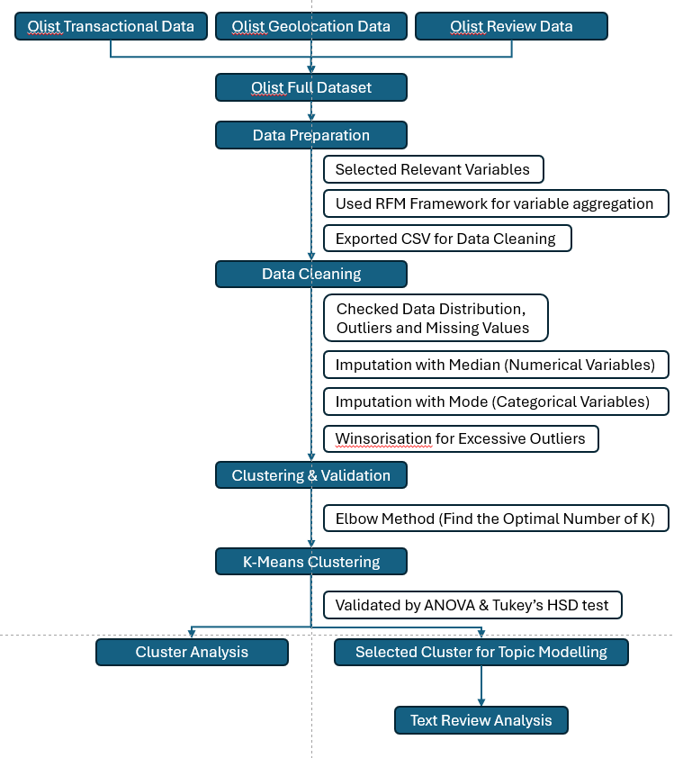
Figure 1: Project Analytical Framework

Research Design
This research adopts a two-stage mixed-methods design. Stage one uses quantitative clustering to identify behavioural customer segments, while stage two applies qualitative topic modelling to understand dissatisfaction within a selected segment. This design reflects the research question: How can customer segmentation and review analysis be combined to generate actionable insights for personalised marketing and service recovery in e-commerce?
The choice of K-Means clustering is grounded in its interpretability and effectiveness for e-commerce segmentation. However, clustering alone only explains what customers do. To address the conceptual gap of understanding why customers behave as they do, BERTopic is employed to extract themes from review text (An et al., 2023). This integration of structured and unstructured data creates a richer analytical lens that aligns with the objectives of developing both segmentation profiles and recovery strategies.

Data Source and Contextual Boundaries
The dataset employed in this study is the Brazilian E-Commerce Public Dataset by Olist (2016–2018), openly available on Kaggle (Olist & André, 2018). It contains multiple relational tables linked through customer and order identifiers, including customers, orders, order items, products, sellers, payments, reviews, and geolocation. In total, it records more than 100,000 orders, involving over 96,000 unique customers and more than 3,000 sellers across 71 product categories, making it one of the richest publicly available datasets for studying e-commerce dynamics.
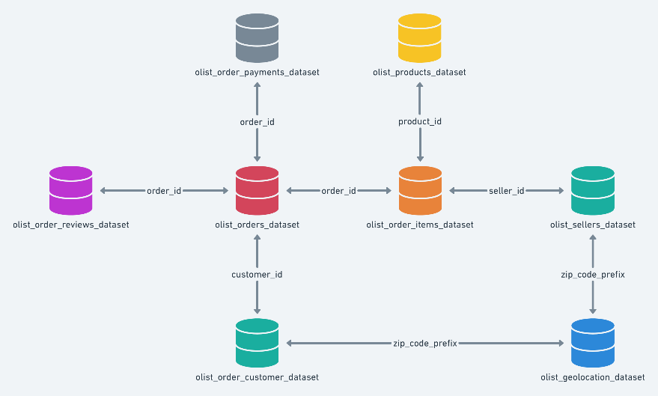
Figure 2: Olist Data Schema (Olist & André, 2018)
Despite its strengths, the dataset has several limitations. It reflects a pre-COVID market context (2016–2018), when digital adoption, payment methods, and logistics systems were markedly different from those in 2025. Customer expectations have since evolved, particularly with the rise of same-day delivery, mobile-first purchasing, and digital wallets. Furthermore, the dataset is Brazil-specific, meaning that findings cannot be directly generalised to other markets with different cultural, economic, and regulatory contexts (Xu et al., 2022). Finally, the review data is voluntary and may over-represent customers with strong positive or negative experiences, introducing a degree of self-selection bias. For these reasons, the findings of this study are framed as methodological insights rather than contemporary predictions of consumer behaviour.

Data Preparation
Before feature selection, the relational tables in the Olist dataset were merged using customer and order identifiers. This integration step was essential for consolidating order, payment, product, and review information into a single analytical dataset. Once the tables had been joined, the merged file was exported as a CSV “full dataset”, providing a consistent and accessible base for subsequent analysis.
After integration, only delivered orders were retained to guarantee that the analysis captured completed transactions aligned with actual customer experiences. From this dataset, a subset of variables was selected based on their relevance to segmentation and satisfaction analysis. Order timestamps were used to calculate recency, customer IDs and order counts were used for frequency, and payment values captured monetary contributions. The number of payment instalments was included to reflect Brazil’s widespread reliance on credit-based purchasing. Product categories enabled the computation of category diversity, while review scores provided a quantitative measure of satisfaction. Finally, review comments were retained for qualitative analysis in the BERTopic stage.
These choices were informed by the Recency–Frequency–Monetary (RFM) framework (Wang et al., 2024), which is widely applied in customer segmentation research. The framework was extended with context-specific features such as payment behaviour, product diversity, and satisfaction indicators, thereby capturing both transactional and experiential aspects of the customer journey.

Data Cleaning
Before applying clustering, the dataset was subjected to a series of cleaning procedures to ensure analytical reliability. The first step involved assessing the extent of missing values. Rather than discarding incomplete records, which could have introduced unnecessary data loss and bias, imputation strategies were adopted (Zhou et al., 2024; Hu et al., 2024). For numerical variables, missing values were replaced using the median, which is more robust to skewed distributions and extreme values. For categorical variables, the mode was used to preserve the most frequent class within the dataset. This approach is widely recognised in the methodological literature as a practical means of retaining sample size while maintaining representativeness (Emmanuel, 2021; Li et al., 2024).

Following this, the distribution of variables was examined to identify skewness or irregular patterns. Inspecting data distribution is particularly important in clustering tasks because algorithms such as K-Means rely on Euclidean distances (Gomes & Meisen, 2023, making them sensitive to scale and variance across variables. Skewed distributions can distort these calculations, potentially leading to biased or unstable cluster solutions.
Finally, attention was directed towards the presence of outliers. Extreme values have the potential to disproportionately influence the placement of cluster centroids, which in turn can compromise the stability of segmentation. To mitigate this issue, winsorisation at the was applied. This method reduces the influence of extreme observations without discarding data points, thereby preserving the overall structure of the dataset while improving the robustness of the clustering process (Khan et al., 2024). This study highlights winsorisation as an effective technique for addressing one of the known limitations of K-Means, its sensitivity to outliers.
Through these steps, imputation, distribution assessment, and outlier treatment, the dataset was refined to better reflect its underlying structure. This process ensured that the subsequent segmentation was built on a stable and representative foundation, reducing the risk of distortions that could otherwise undermine the validity of results.

Clustering and Validation
K-Means clustering was chosen for its efficiency, scalability, and established role in customer segmentation research. Its reliance on centroid-based partitioning produces clusters that are easy to interpret and profile, which is particularly valuable in an e-commerce context where managers require actionable insights rather than purely technical solutions (Sinaga & Yang, 2020). The Elbow Method was used to determine the optimal number of clusters by balancing the trade-off between model complexity and explanatory clarity, ensuring that the segmentation remained both parsimonious and meaningful.
To validate the solution (Pedro et al., 2024), ANOVA tests were conducted to assess whether behavioural variables significantly differed across clusters, with Tukey’s HSD applied to identify specific inter-group differences. This statistical validation step is important because clustering algorithms alone do not guarantee meaningful separation; without it, segmentation risks becoming arbitrary. By combining K-Means with ANOVA/Tukey validation, the methodology ensured that the resulting groups reflected genuine behavioural heterogeneity, thereby directly supporting the research objective of producing actionable customer segments for targeted marketing and service recovery.

Cluster Selection
After the clustering stage was completed, the results were examined to compare customer satisfaction across groups, with review scores serving as a proxy for satisfaction. The aim was to identify whether any cluster showed systematically lower scores relative to the others. The cluster that exhibited noticeably lower satisfaction was then selected as the focal group for the next stage of analysis.
In this subsequent stage, topic modelling was applied to the review comments of the selected cluster. The purpose of this step was to explore the reasons underlying the lower ratings and to gain deeper insight into the issues that customers were experiencing. This approach allowed the study to move beyond behavioural segmentation and connect it with customer perceptions, setting the basis for later identifying potential strategies to address the problems once the results are presented.

Topic Modelling with BERTopic
In the subsequent stage of analysis, review comments from the selected cluster were analysed using BERTopic, as outlined by Grootendorst (2022). BERTopic constructs document embeddings from pre-trained transformer models, applies dimensionality reduction (UMAP) and density-based clustering (HDBSCAN), and generates interpretable topics using a class-based TF-IDF procedure. This approach has been shown to outperform traditional topic modeling techniques, such as Latent Dirichlet Allocation (LDA) in generating semantically coherent and diverse themes, especially within the context of short texts. The study by Muriël et al. (2022) confirmed that BERTopic yielded higher topic coherence and diversity compared to LDA when applied to multi-domain short text corpora, underscoring its suitability for analysing brief and informal customer reviews.
This methodological choice supports the study’s objective by providing a robust mechanism for uncovering underlying themes from short, noisy e-commerce reviews making the results more actionable for managerial decision-making. It bridges the gap between structured behavioural segmentation and unstructured sentiment extraction, enabling nuanced insight without sacrificing interpretability.

Ethical Considerations
This study uses a dataset that is publicly available and anonymised, minimising risks to individual privacy. Additionally, the dataset is distributed under the Creative Commons Attribution–NonCommercial–ShareAlike 4.0 (CC BY-NC-SA 4.0) license (Labastida & Margoni, 2019), allowing for non-commercial use, requiring attribution, and mandating that derivative works be shared under the same terms. Including license information is an important ethical consideration in data reuse, clarifying the permitted scope of use and promoting legal transparency.
In addition to the licensing issue, there are a few caveats to be made about the dataset. In the process of creating this dataset, the assumption is made that the reviews reflect the actual customer experience, but there was no verification as to how this data could have been biased and manipulated. The dataset also uses the translation from Portuguese to English of the reviews, potentially leading to semantic issues. Furthermore, since the data is based on users’ behaviour in 2016–2018, and given the fast-changing nature of online shopping, this work does not claim to have predictive capabilities regarding the present or the future state of the e-commerce field, but only focuses on the methodological contribution. Taking into account the above-mentioned caveats regarding the licensing, anonymity, and possible biases in the dataset should be seen as an act of responsible research.

Results

Descriptive Analysis
The descriptive statistics provided an overview of customer purchasing patterns and popular product categories. The top-selling product categories were bed_bath_table and health_beauty, each exceeding 8,000 purchases, followed by sports_leisure and computers_accessories with around 7,000 and 6,300 purchases, respectively. These results indicate that household items, personal care, and lifestyle products are among the most in-demand categories.
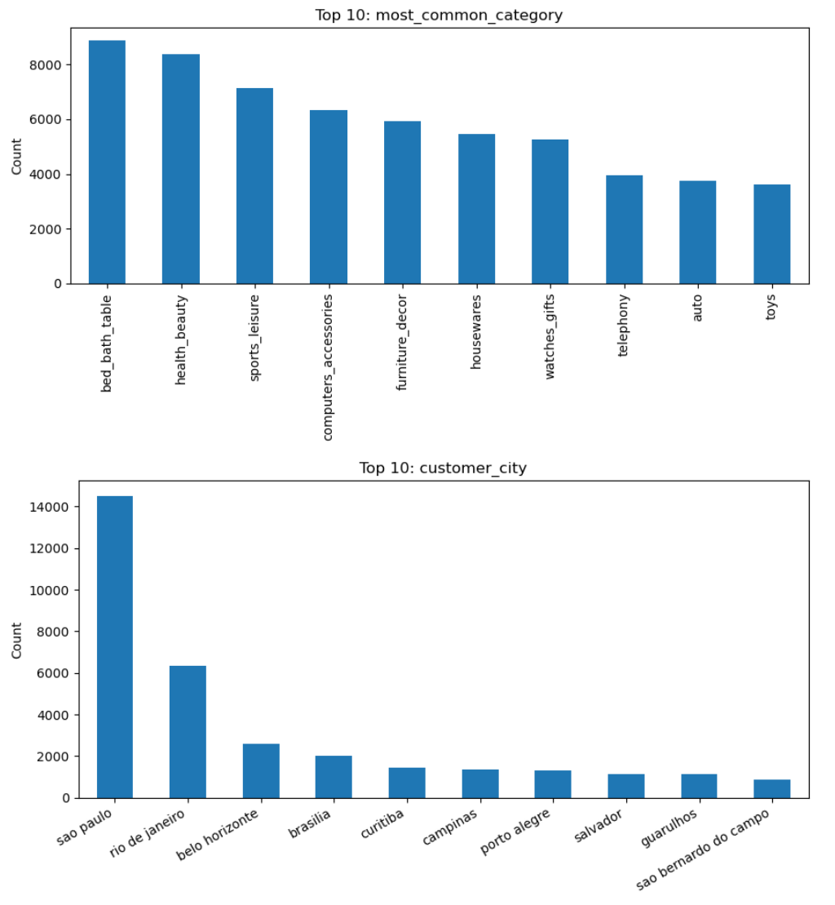
Figure 3: The Most Common Category of Products
In terms of customer location, demand was heavily concentrated in large metropolitan areas. São Paulo dominated with over 14,000 customers, followed by Rio de Janeiro with around 6,300. Other cities such as Belo Horizonte, Brasília, and Curitiba contributed smaller but still significant shares. This distribution highlights the geographical concentration of e-commerce activity in Brazil’s largest urban centres.

Figure 4: Top 10 of Customers’ city in Brazil

Elbow Method
Figure X presents the Elbow Method plot, which shows a steep reduction in inertia between k = 1 and k = 4 before the curve begins to flatten. At k = 5, the inflection point becomes clear, indicating that most of the variance reduction is captured by this stage. Choosing five clusters therefore provides a balance between statistical fit and interpretability: selecting four clusters would oversimplify customer heterogeneity by merging distinct behaviours, while six clusters would only marginally improve compactness but risk fragmenting the dataset into smaller groups that are less actionable. Similar approaches have been adopted in prior e-commerce segmentation research, where K-Means with five to six clusters was found to provide practical and interpretable results (Tabianan et al., 2022; Gomes & Meisen, 2023). Although the Elbow Method is heuristic and somewhat subjective, its use remains a widely recognised standard for identifying an appropriate number of clusters in business analytics applications (Kodinariya & Makwana, 2013).
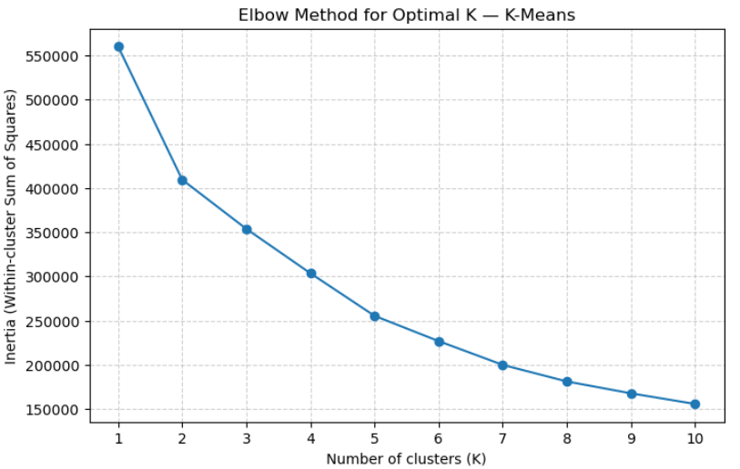
Figure 5: Elbow Method for Clustering

Clustering Results
The K-Means algorithm was applied to segment customers into five clusters based on purchasing behaviour, order value, payment preferences, review scores, and recency.
Cluster 0 (n=17,959): Medium-sized cluster with higher spending (≈ 338 BRL) and large order values (≈ 282 BRL). These customers often used more payment instalments (≈ 5.4), making them a segment of high-value buyers.
Cluster 1 (n=35,337): The largest cluster, characterised by low total spend (≈ 98 BRL), low average order value (≈ 92 BRL), and shorter recency (≈ 125 days). Customers in this group tend to make smaller, more recent purchases with relatively high review scores (≈ 4.7).
Cluster 2 (n=2,161): The smallest but distinct cluster, with above-average spend (≈ 294 BRL) and order values (≈ 157 BRL), paired with higher category diversity (≈ 2.07). This group represents variety-seeking buyers.
Cluster 3 (n=12,512): Customers with low review scores (≈ 1.7), moderate spending, and longer recency. This segment appears to include dissatisfied or disengaged customers.
Cluster 4 (n=25,389): Similar to Cluster 1 in terms of low spending and order value, but with much longer recency (≈ 398 days), suggesting a group of inactive or churned customers.
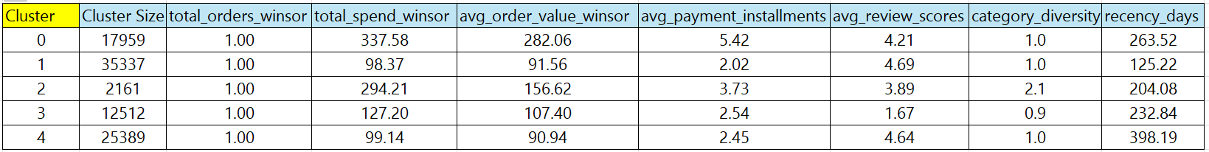
Figure 6: Cluster Analysis Results

ANOVA Results
The ANOVA test confirmed that differences across clusters were statistically significant for most features. All six variables (total spend, average order value, payment instalments, review score, category diversity, and recency) showed p-values < 0.05, indicating that they significantly contributed to differentiating customer groups.
The strongest differences were observed in total spend (F=44,248) and average order value (F=40,894), followed by category diversity and review score, showing that spending behaviour and satisfaction levels are the main drivers of segmentation.
The only variable without statistical difference was total_orders_winsor, which was constant across groups, meaning frequency of orders was not a distinguishing factor in this analysis.
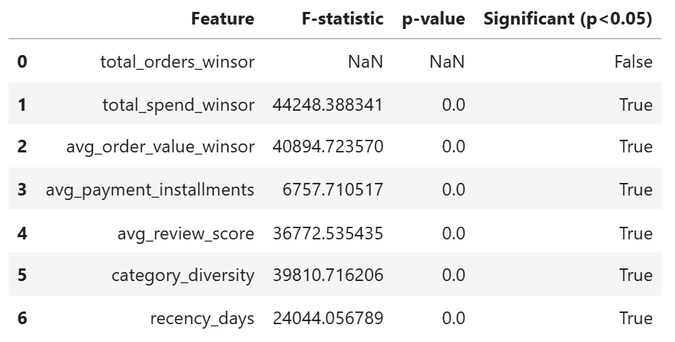
Figure 7: ANOVA test Results

Tukey’s Post-Hoc Results
In terms of total spend and average order value, customers in Clusters 0 and 2 were clearly set apart from the others. Cluster 0 showed the highest spending behaviour, with order values much larger than those in Clusters 1, 3, and 4. Cluster 2 also spent significantly more than the low-value clusters, but its values were still lower than Cluster 0. On the other hand, Clusters 1 and 4 showed no meaningful difference between them, confirming that they both represented groups of low-spending customers.
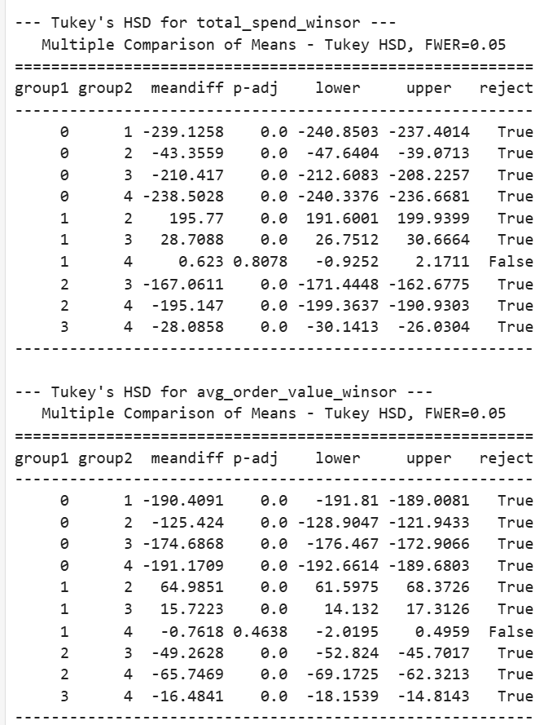
Figure 8: Tukey's HSD result for total_spend_winsor variable


Figure 9:Tukey's HSD result for avg_order__value_winsor variable

The results for payment instalments showed that Cluster 0 was the only group with consistently high use of instalments, which distinguished it from all others. While Clusters 1, 3, and 4 had very similar and low levels of instalment use, Cluster 2 stood in the middle, slightly above the low-value groups but below Cluster 0. This pattern suggests that customers making larger purchases rely more heavily on instalment options.
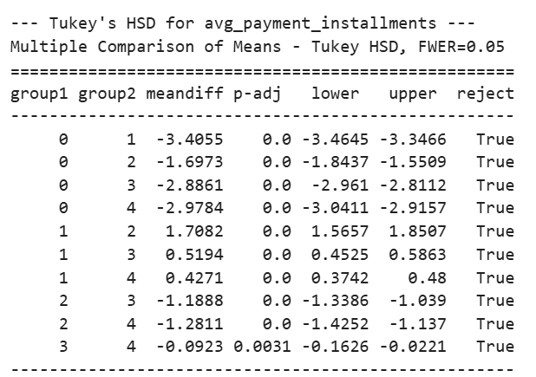
Figure 10: Tukey's HSD result for avg_payment_installments variable

When looking at review scores, Cluster 3 was significantly different from the rest. Its customers gave very low scores, indicating dissatisfaction, while the other groups gave much higher ratings. Clusters 1 and 4 were particularly notable, as despite their low spending, they gave the highest satisfaction ratings. Cluster 0’s scores were moderately positive, and Cluster 2 showed lower satisfaction compared to the other high-spend group.
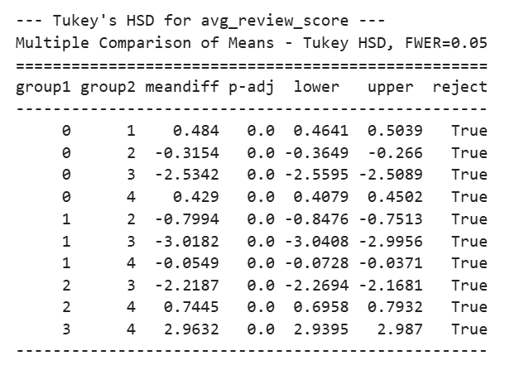
Figure 11: Tukey's HSD result for avg_review_score variable

For category diversity, only Cluster 2 stood out. Its customers bought from a much wider range of product categories, making them very different from the rest, who tended to shop within a smaller number of categories.
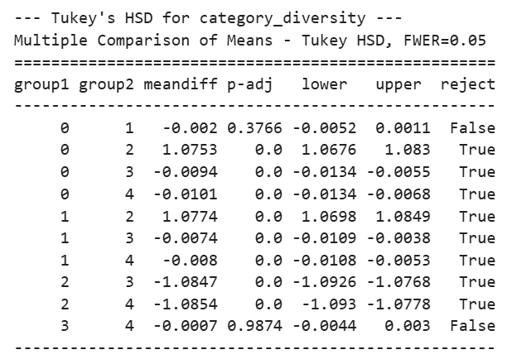
Figure 12: Tukey's HSD result for category_diversity variable
Finally, the results for recency showed that Cluster 4 had been inactive for the longest period, with purchase activity far behind the other groups. Cluster 1, by contrast, was the most recent, suggesting that these customers are still engaged. Clusters 0 and 3 also had longer recency periods, showing more irregular purchase behaviour compared with Cluster 1.
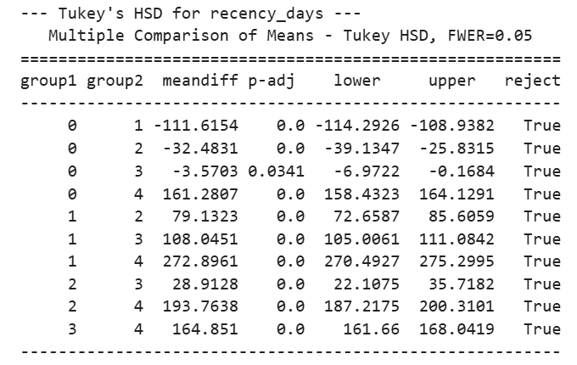
Figure 13: Tukey's HSD result for recency_days variable
Overall, the Tukey test reinforced the differences found in the clustering. Cluster 0 emerged as high-value and instalment-driven, Cluster 2 as high-spending but variety-seeking, Cluster 1 as low-spend but satisfied and active, Cluster 4 as low-spend and inactive, and Cluster 3 as dissatisfied customers with moderate spending.

Selected Cluster for Deeper Analysis
From the clustering stage, Cluster 3 was chosen for deeper investigation. This decision was based on two main reasons. First, this cluster contained over 12,000 customers, representing a sizable portion of the dataset. Second, it was distinctive in its profile: customers in this group had moderate spending levels but gave extremely low review scores (≈ 1.7). This makes them a critical segment for business strategy, as their dissatisfaction poses a risk of churn, reputational damage, and lost revenue if their concerns remain unresolved. By examining their reviews more closely, it becomes possible to identify the underlying problems driving this negative sentiment.

Customer Review Analysis (BERTopic)
The BERTopic model was applied to reviews from Cluster 3, generating ten distinct topics that captured customer concerns and recurring themes. Together, they revealed the underlying reasons for the extremely low satisfaction scores in this cluster.
Topic 1 – Damaged or broken products: Customers frequently mentioned items arriving damaged or poorly packaged, with terms like “produto danificado”, “embalagem”, and “caixa veio quebrada”.
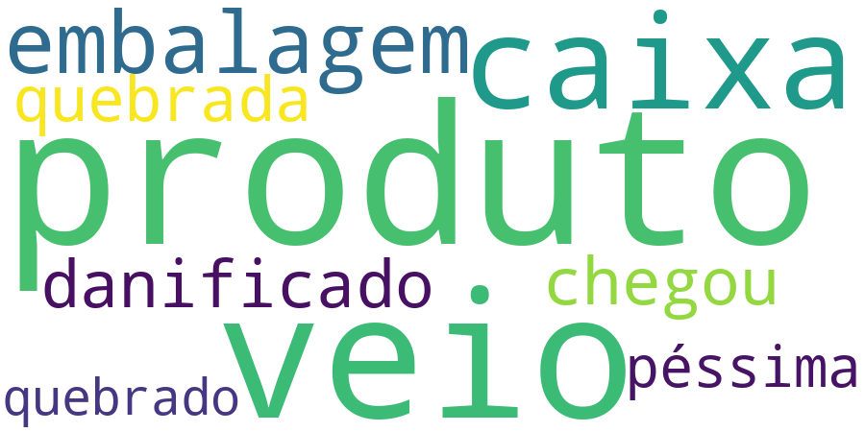
Figure 14: Word Cloud of Topic 1
Topic 2 – Negative store experiences: Words such as “nunca compro” and “não recomendo” indicated that many customers had lost trust in certain sellers and actively discouraged others from buying from them.
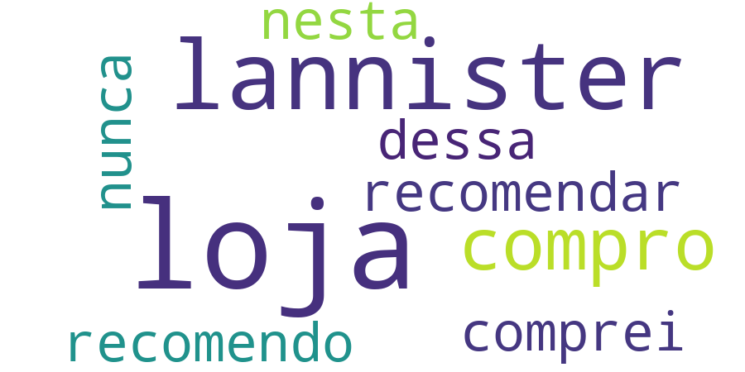
Figure 15: Word Cloud of Topic 2
Topic 3 – Wrong product attributes: Several customers complained about receiving the wrong variation, particularly in terms of colour, e.g., “produto veio cor errada”.

Figure 16: Word Cloud of Topic 3
Topic 4 – Requests and complaints: Reviews included terms like “solicito” (I request), “pedi” (I asked for), and “porém” (however). This suggests that many customers were formally requesting refunds, replacements, or raising complaints, highlighting dissatisfaction that escalated into after-sales disputes.

Figure 17: Word Cloud of Topic 4
Topic 5 – Product not yet received: Customers used phrases such as “produto ainda”, “produto agora”, and “ainda produto”, which pointed to frustration with items that had not been delivered at the expected time. This overlaps with delivery delays but also indicates anxiety over incomplete transactions.

Figure 18: Word Cloud of Topic 5
Topic 6 – Defective items: This theme was common for watches and electronics, with words like “relógio veio defeito” and “chegou defeito”, showing dissatisfaction with faulty products.
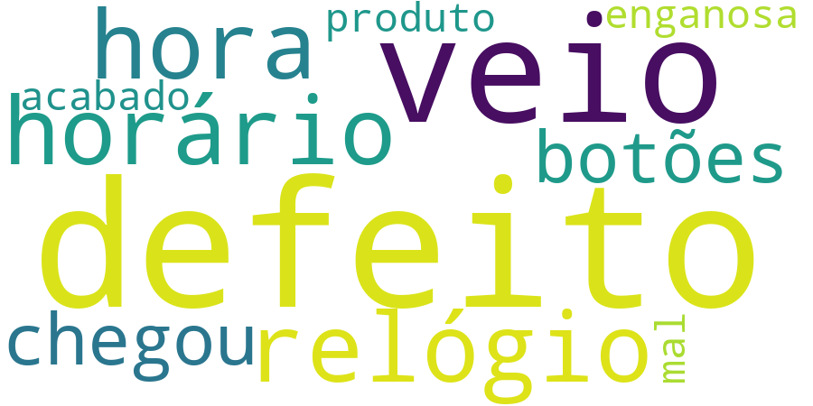
Figure 19: Word Cloud of Topic 6
Topic 7 – Order cancellations and delays: Complaints focused on long delivery times and cancellations, using terms like “cancelamento” and “demora entregar”.
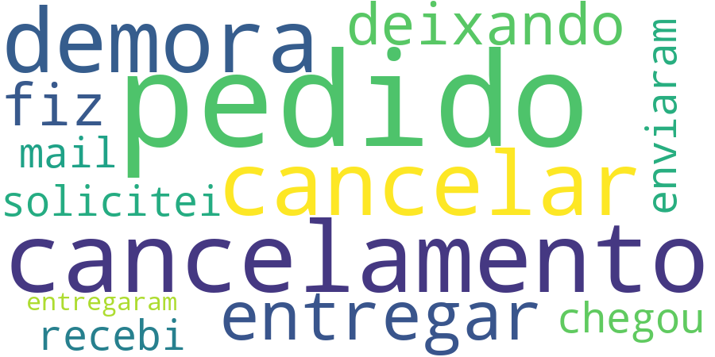
Figure 20: Word Cloud of Topic 7
Topic 8 – Poor quality perception: Customers highlighted dissatisfaction with product standards using words like “baixa qualidade” and “qualidade ruim”.

Figure 21: Word Cloud of Topic 8
Topic 9 – Delivery dates and delays: Terms such as “prazo entrega” and “recebi prazo” showed concerns around late deliveries and unmet deadlines.

Figure 22:Word Cloud of Topic 9
The word clouds reinforced these findings. For example, Topic 1 prominently displayed “produto”, “caixa”, “embalagem”, “danificado”, pointing to damaged packaging. Topic 2 included “loja”, “nunca”, “não recomendo”, showing distrust towards sellers. Topic 3 contained “cor”, “vermelho”, “veio errado”, underlining wrong product variations. Meanwhile, Topic 4 and Topic 5 added another dimension: requests, claims, and undelivered products, highlighting a deeper breakdown in customer experience beyond just quality and logistics.
Overall sentiment across these topics was highly negative. The reviews consistently revealed issues with logistics, delivery reliability, product quality, seller trust, and after-sales service.

Keyword Diversity
The model achieved an overall keyword diversity of 0.556, indicating a moderate level of variation in the top words across topics. This suggests that while some keywords were repeated across topics (e.g., “produto”, “veio”), there was still enough variety to capture different aspects of customer complaints.
Topics such as Topic 8 (low quality) and Topic 5 (product not received) demonstrated good diversity, with terms like “baixa qualidade”, “qualidade inferior”, and “produto ainda” offering a range of expressions around quality and delivery issues.
By contrast, Topic 0 (multiple products purchased) and Topic 3 (wrong colour/product variation) had slightly lower diversity since many reviews repeated near-identical phrases such as “comprei dois” or “produto veio cor errada”.
The moderate overall diversity is appropriate in this case, it shows that the model picked up both broad complaint categories and narrow, recurring issues, which is useful for identifying specific operational problems.

Semantic Coherence
The model also achieved an average semantic coherence of 0.641, which is a solid result and suggests that most topics are internally consistent. Looking at the per-topic scores:
High coherence topics included Topic 8 (low quality) with a coherence of 0.773, the highest score, showing that complaints about product quality were strongly and consistently expressed. Topic 5 (not received) also scored high (0.679), reflecting a clear theme around missing products. Topic 4 (requests and claims) was similarly strong (0.742), indicating focused complaints where customers explicitly requested refunds or replacements.
Moderate coherence topics included Topic 0 (multiple purchases) and Topic 3 (wrong colour), both around 0.61–0.64, meaning these were still clear but had some variability in expression.
Lower coherence topics included Topic 2 (negative store experiences, 0.615), Topic 7 (cancellations and delays, 0.628), and Topic 9 (delivery dates, 0.551). These themes were valid, but customers expressed them with more fragmented or varied language, making them less tightly clustered.
The lowest coherence was seen in Topic 6 (defective watches/electronics, 0.503), where wording varied more widely, though the underlying issue (faulty goods) was still clear.
The model produced topics with generally strong coherence, especially those tied to tangible product or quality issues, while topics linked to store reputation or delivery logistics were weaker, reflecting more varied ways that customers voiced these frustrations.

Discussion

Cluster Profiles and Interpretation
The resulting clustering solution identified five unique groups of customers in Olist’s marketplace, based on their behaviour and experience. The profiles of these five clusters can be described in a variety of ways, focusing on their differences and similarities. Not only can we observe these differences in their level of spending, satisfaction, and engagement, but also paradoxical patterns in their profiles that could potentially challenge certain assumptions in theory and managerial practice
Cluster 0 – High-value, instalment-driven buyers.
This group has the highest levels of expenditure, with large average order values and a heavy dependence on instalment payments. It can be said that they are financially committed customers who are however risk-averse and thus prefer to pay for their purchases in multiple instalments. This seems to tie in with other studies of Brazilian e-commerce, which identify the culture of credit and instalment as being a key dimension of online consumer practice (Valdivino et al., 2025). From a theoretical point of view, this could be framed in terms of Justice Theory, specifically procedural fairness, with customers expecting payment systems to be both flexible (allowing instalments) and fair (allowing them to rely on the system). From a management perspective, it can be said that the Cluster 0 group embodies the need for premium service guarantees, since they are the group of the highest strategic value to the organisation due to their high financial value.
Cluster 1 – Low spend, satisfied, recent buyers.
Cluster 1 is a paradox in its own sense. It is the largest cluster, yet it brings in almost no monetary value. However, these customers have the highest level of satisfaction and are the most recent buyers. The reason for this anomaly can be justified by the Expectation–Confirmation Theory (Bhattacherjee, 2001): customers may have set low expectations that can be easily confirmed by even the most basic or the least costly transaction. Their level of satisfaction indicates that customers’ potential loyalty cannot be determined by their spending alone. On the contrary, this group shows that the first impression is the key to building long-term trust. These customers are low value in the short-term perspective, yet can be a valuable base to nurture.

Cluster 2 – Variety-seeking, mid-to-high spenders.
The smallest but behaviourally distinctive cluster. Customers buy across many categories and spend at above-average levels, but have mixed satisfaction scores. This reflects known variety-seeking behaviour in consumer markets (Gupta et al., 2023). The mix of reviews also reflects variability in seller quality between categories, which may be seen as validation of SERVQUAL’s reliability dimension: it’s not just about overall value, but consistency as well. This cluster may suggest that platform heterogeneity in seller performance translates directly into inconsistent experiences for customers.
Cluster 3 – Dissatisfied, moderate spenders.
Cluster 3 is the most interesting and important from a theoretical and managerial perspective. Despite medium spending, these customers have the lowest satisfaction levels, with an average rating of approximately 1.7. Topic modelling of their reviews showed consistent complaints about late delivery, damaged products, wrong attributes, and untrustworthy sellers. This directly confirms Xu et al. (2022), who highlighted gaps in Olist’s order and logistics management system. Theoretically, this cluster challenges traditional loyalty models that associate high spend with satisfaction and loyalty (Kevrekidis et al., 2017). Instead, SERVQUAL (Parasuraman et al., 1988) and Justice Theory (Tax et al., 1998) explain their negative feelings. Failures in reliability, responsiveness and justice outweigh transactional value for these customers. They represent the risk of failing to prioritize service quality in e-commerce competition.
Cluster 4 – Inactive, low spenders.
Customers in this group are low value with long recency, suggesting disengagement or churn. Their satisfaction scores are moderate, but the lack of repeat engagement underscores a central paradox in retention research: satisfaction is necessary but not sufficient for loyalty (Bleier & Eisenbeiss, 2015). Without reactivation efforts, even satisfied customers can lapse if they have no incentive or opportunity to switch.

Paradoxes Identified
The most noteworthy paradox is between Cluster 1 and Cluster 3. Customers in Cluster 1, who contribute the least revenue, exhibit the highest levels of satisfaction and engagement. In contrast, Cluster 3 customers, who spend the most, are the least satisfied. This paradox challenges the assumption that financial contribution correlates with satisfaction and loyalty. Theoretical frameworks offer insights. Expectation Confirmation Theory, for example, could explain Cluster 1's high satisfaction through the lens of modest expectations that were easily surpassed. However, the dissatisfaction of Cluster 3 might be better explained by the SERVQUAL and Justice Theory. Operational failures eroded trust, irrespective of the spend level. This paradox is the conceptual contribution: it illustrates that satisfaction and spending do not scale linearly but are mediated by the quality of the experiential encounter.

Managerial Implications
The results of the analysis directly inform the management of Olist and other e-commerce retailers, by providing a direct set of actions for each identified segment of customers. The implications of the findings relate to both marketing and operational levers, while being firmly grounded on the theory and empirics of the literature review.
Cluster 0 (high-value, instalment-driven buyers), the goal is to maintain trust and loyalty among financially committed customers. Platforms should consider offering premium after-sales services, like priority support lines or dedicated account managers. Fraud detection measures and stricter monitoring of high-value instalment transactions should be in place to preserve procedural fairness (Tax et al., 1998; Justice Theory). Exclusive loyalty tiers, such as early access to promotions or priority delivery slots, would also strengthen engagement, in line with recent findings on customer relationship management focusing on retaining high-value buyers (Kaur, 2024).

Cluster 1 (low spend, satisfied buyers), while they may not be as important for short-term revenues, have significant growth potential that should be considered. Due to their high levels of satisfaction, their expectations must be exceeded as per Expectation–Confirmation Theory (Bhattacherjee, 2001). Programmatic investments for retention journeys and expansion of this cluster through tailored onboarding journeys, referral programmes and gamified rewards structures should be considered by managers. Referral-based and gamified re-engagement have been recently proven to increase the word-of-mouth effect and subsequent long-term loyalty of satisfied entry-level customers (Kumar & Reinartz, 2016). Slow and steady upselling through custom offers will increase customer lifetime value as small but satisfied buyers can become more profitable customers over time.
Cluster 2 (variety-seeking spenders), the variable scores are influenced by the fact that customers have encountered problems in some product categories while being satisfied with others. To tackle this, companies can use audits on product quality tailored to specific categories in order to boost weak ones, in line with recent findings that most product returns in online retail are highly concentrated in a handful of categories (Mor et al., 2024). Personalised cross-category bundles and curated recommendations can be used to direct variety-seeking customers towards products from reputable sellers, and transparency dashboards that display seller ratings can act as trusted signals to minimise ambiguity.
Cluster 3 (dissatisfied, moderate spenders) is the most pressing segment for managers. These customers are not among the most valuable in the segmentation analysis but are highly dissatisfied, posing reputational risks and potential churn. In the service recovery literature, it is consistently found that recovery needs to be multi-dimensional and targeted rather than adopting a "one size fits all" approach (Lim et al., 2025). The following four evidence-based recovery tactics are relevant for this customer segment: (1) refunds or replacements, to address distributive justice; (2) expedited or guaranteed delivery options, to restore reliability and address SERVQUAL's reliability dimension (Parasuraman et al., 1988); (3) loyalty credits or discount vouchers, to put the Service Recovery Paradox in place and in practice (Smith & Bolton, 1998; Lim et al., 2025), whereby a well-handled recovery can actually result in even higher loyalty than before; and (4) transparent complaint handling, providing clear timelines and structured follow-ups, to enhance both procedural and interactional justice. In addition, from an operational perspective, Olist should enhance their logistics partnerships with stricter service-level agreements and penalties, introduce a verified seller badge with repercussions for not adhering to Olist's quality standards, implement real-time delivery tracking, and establish a dedicated recovery unit that integrates customer service, logistics, and seller management teams. This combination of interventions aims at addressing both the symptoms and the root causes of dissatisfaction, in line with recent evidence that successful recovery combined with operational improvements leads to long-term loyalty (Lim et al., 2025).
Finally, Cluster 4 (inactive low spenders) need reactivation strategies to avert permanent churn. Multi-channel win-back campaigns, leveraging email, WhatsApp, and in-app push notifications, outperform single-channel interventions in digital commerce (Santoso & Sudarmiatin, 2024). Seasonal promotions and dynamic coupons can be particularly effective, as this segment shows price sensitivity. Collecting feedback through surveys can systematically capture reasons for disengagement, in line with voice-of-customer frameworks.
The above recommendations, collectively, show that there is no one-size-fits-all. Rather, managers need to weigh providing premium service to big spenders, offering growth paths to satisfied new customers, delivering consistent service to variety seekers, attempting to recover dissatisfied heavy spenders, and reactivating inactive customers, among other things. Perhaps most importantly, the paradox between Clusters 1 and 3 teaches that satisfaction is not a function of one's ability or willingness to spend. Therefore, any attempt to take managerial action must involve not only marketing strategies, but also operational changes that ensure that the promises made are kept in practice.

Conclusion
The project's contribution is multifold and may be organised according to the stated objectives. With respect to the goal of identifying customer clusters, the objectives were achieved, with the use of three selected features in the final cluster definition. For the objective of performing topic modelling to elicit themes for customer dissatisfaction, this was also realised and substantiated with further qualitative review inspection. The third objective of bridging quantitative and qualitative methods was duly executed. However, of greater significance are the paradoxes identified with the analysis that call for consideration in future research. In one observation, lower-value customers (in terms of purchase spend) who are flagged as dissatisfied based on the review scoring, have a contrasting indication when the latent topic modelling results are taken into account, suggesting satisfaction. A similar dissonance in experience is found for a moderate-value customer cluster.
The aforementioned paradoxes bring to light certain shortfalls of existing theory or their misapplication. The common practice of segmenting value in terms of financial contribution is contrasted in the findings that indicate that spending is not the key to loyalty (however, it is of course the key to revenue). The oft-touted dimensions of service quality (SERVQUAL), reliability, and assurance (Zarb & Sajjad, 2020), are contradicted by the empirically-supported suggestion that customer experiences in B2C commerce cut across dimensions in more complex and less predictable ways. Additionally, the very linear concept of a loyalty continuum is brought into question. Managerially, the implication is that service recovery in e-commerce must not be siloed as a marketing function whose remit is to proffer the usual levers of credits, referrals and refunds. Rather, it is a cross-cutting exercise that must work in parallel with operational measures such as service-level agreements with service providers, especially logistics partners and onboarding and seller-verification controls with marketplaces. In other words, delivery and refund become the two sides of a coin whose value can only be maximised when both are considered.
The project is not without its limitations, however. The most proximal is the datedness of the data set (2016–2018). This is also a relatively old marketplace in terms of e-commerce maturity. The reviews were collected through self-selection and translated from native to English, adding layers of potential bias. The K-Means modelling was an oversimplification of customer heterogeneity. The coherence of BERTopic topic modelling was noted to be inconsistent. The project deployed existing theoretical frameworks without proposing novel models. The causal mechanisms behind the analysis have not been substantiated. Cognizant of the limitations, future work in this area may take the three-phase hybrid approach to other data sets and marketplaces. These should be larger and more recent (after 2020), to test the validity of the approach across a representative sample of the global B2C e-commerce market. They may also be in the same geographical region, to control for cross-cultural factors (marketing and management scholarship in this area is voluminous, see for example Hofstede & Hofstede, 2010). Methodologically, an alternative to k-Means clustering may be more appropriate, as may be more advanced NLP for topic modelling. A formalised hybrid framework (building on Zhang, 2015) that meaningfully links segmentation to service quality can be further developed. The circumstances under which the Service Recovery Paradox holds can be rigorously tested using an A/B experiment.
In conclusion, the study makes contributions conceptually by challenging taken-for-granted assumptions in segmentation and service quality and practically by showcasing the potential value of hybrid behavioural and experiential data and integrated management approaches in e-commerce.

Reference lists
Ali, F., Hacioglu, U., & Zehir, M. (2025). Building brand loyalty through digital marketing: insights from young airline travelers. Bussecon Review of Social Sciences (2687- 2285), 7(1), 22–31. https://doi.org/10.36096/brss.v7i1.799
An, Y., Oh, H., & Lee, J. (2023). Marketing Insights from Reviews Using Topic Modeling with BERTopic and Deep Clustering Network. Applied Sciences, 13(16), 9443. https://doi.org/10.3390/app13169443
Bhattacherjee, A. (2001). Understanding Information Systems Continuance: An Expectation-Confirmation Model. MIS Quarterly, 25(3), 351. https://doi.org/10.2307/3250921
Bleier, A., & Eisenbeiss, M. (2015). The importance of trust for personalized online advertising. Journal of Retailing, 91(3), 390–409. https://doi.org/10.1016/j.jretai.2015.04.001
Cai, Y. (2025). Digital divide. In Living reference work entry (pp. 1–6). https://doi.org/10.1007/978-3-319-99675-2_9646-1
Correa, J. C., Laverde-Rojas, H., Martínez, C. A., Camargo, O. J., Rojas-Matute, G., & Sandoval-Escobar, M. (2021). The consistency of Trust-Sales relationship in Latin American E-Commerce. Journal of Internet Commerce, 21(4), 476–496. https://doi.org/10.1080/15332861.2021.1975426
Da Veiga, C. P., Da Veiga, C. R. P., De Souza Silva Michel, J., Di Iorio, L. F., & Su, Z. (2024). E-Commerce in Brazil: An In-Depth Analysis of Digital Growth and Strategic Approaches for Online retail. Journal of Theoretical and Applied Electronic Commerce Research, 19(2), 1559–1579. https://doi.org/10.3390/jtaer19020076
Dibb, S., & Simkin, L. (2010). Judging the quality of customer segments: segmentation effectiveness. Journal of Strategic Marketing, 18(2), 113–131. https://doi.org/10.1080/09652540903537048
Dieng, A. B., Ruiz, F. J. R., & Blei, D. M. (2020). Topic Modeling in embedding spaces. Transactions of the Association for Computational Linguistics, 8, 439–453. https://doi.org/10.1162/tacl_a_00325
Dujardin, A. (2025). 13 key global e-commerce stats every e-tailer should know | TextMaster. The International Expansion Blog. https://www.textmaster.com/blog/e commerce-global-statistics-2025
Emmanuel, T., Maupong, T., Mpoeleng, D., Semong, T., Mphago, B., & Tabona, O. (2021). A survey on missing data in machine learning. Journal of Big Data, 8(1). https://doi.org/10.1186/s40537-021-00516-9
Gomes, A. C., De Lima, F. B., Junior, Soliani, R. D., De Souza Oliveira, P. R., De Oliveira, D. A., Siqueira, R. M., Da Silva Nora, L. a. R., & De Macêdo, J. J. S. (2023). Logistics management in e-commerce: challenges and opportunities. Revista De Gestão E Secretariado (Management and Administrative Professional Review), 14(5), 7252–7272. https://doi.org/10.7769/gesec.v14i5.2119
Gomes, M. A., & Meisen, T. (2023). A review on customer segmentation methods for personalized customer targeting in e-commerce use cases. Information Systems and e-Business Management, 21(3), 527–570. https://doi.org/10.1007/s10257-023- 00640-4
Griva, A. (2022). “I can get no e-satisfaction”. What analytics say? Evidence using satisfaction data from e-commerce. Journal of Retailing and Consumer Services, 66, 102954. https://doi.org/10.1016/j.jretconser.2022.102954
Grootendorst, M. (2022). BERTopic: Neural topic modeling with a class-based TF-IDF procedure. arXiv (Cornell University). https://doi.org/10.48550/arxiv.2203.05794
Guney, S., Peker, S., & Turhan, C. (2020). A combined approach for customer profiling in video on demand services using clustering and association rule mining. IEEE Access, 8, 84326–84335. https://doi.org/10.1109/access.2020.2992064
Gupta, S., Kushwaha, P., Badhera, U., Chatterjee, P., & Gonzalez, E. D. S. (2023). Identification of benefits, challenges, and pathways in E-commerce industries: An integrated two-phase decision-making model. Sustainable Operations and Computers, 4, 200–218. https://doi.org/10.1016/j.susoc.2023.08.005
Hassan, N., Abdelraouf, M., & El-Shihy, D. (2025). The moderating role of personalized recommendations in the trust–satisfaction–loyalty relationship: an empirical study of AI-driven e-commerce. Future Business Journal, 11(1). https://doi.org/10.1186/s43093-025-00476-z
Hong, T., & Kim, E. (2011). Segmenting customers in online stores based on factors that affect the customer’s intention to purchase. Expert Systems With Applications, 39(2), 2127–2131. https://doi.org/10.1016/j.eswa.2011.07.114
Hu, Y., Wu, R., Lin, Y., & Lin, T. (2024). A novel MissForest-based missing values imputation approach with recursive feature elimination in medical applications. BMC Medical Research Methodology, 24(1). https://doi.org/10.1186/s12874-024-02392-2
Joung, J., & Kim, H. (2023). Interpretable machine learning-based approach for customer segmentation for new product development from online product reviews. International Journal of Information Management, 70, 102641. https://doi.org/10.1016/j.ijinfomgt.2023.102641
Kaur, H. (2024). The impact of loyalty programs on customer retention in the retail industry. Deleted Journal, 12(3), 69–82. https://doi.org/10.36676/dira.v12.i3.57
Kevrekidis, D. P., Minarikova, D., Markos, A., Malovecka, I., & Minarik, P. (2017). Community pharmacy customer segmentation based on factors influencing their selection of pharmacy and over-the-counter medicines. Saudi Pharmaceutical Journal, 26(1), 33–43. https://doi.org/10.1016/j.jsps.2017.11.002
Khan, I. K., Daud, H. B., Zainuddin, N. B., Sokkalingam, R., Abdussamad, N., Museeb, A., & Inayat, A. (2024). Addressing limitations of the K-means clustering algorithm: outliers, non-spherical data, and optimal cluster selection. AIMS Mathematics, 9(9), 25070–25097. https://doi.org/10.3934/math.20241222
Kim, J., Kim, M., Im, S., & Choi, D. (2021). Competitiveness of E Commerce Firms through ESG Logistics. Sustainability, 13(20), 11548. https://doi.org/10.3390/su132011548
Klaus, P. ‘., & Maklan, S. (2013). Towards a better measure of customer experience. International Journal of Market Research, 55(2), 227–246. https://doi.org/10.2501/ijmr-2013-021
Kodinariya, T. M., & Makwana, P. R. (2013). Review on determining the number of clusters in K-Means clustering. International Journal of Advance Research in Computer Science and Management Studies, 1(6), 90–95. https://www.researchgate.net/publication/313554124_Review_on_Determining_of_ Cluster_in_K-means_Clustering
Kumar, N. (2025). Intelligent customer segmentation: unveiling consumer patterns with machine learning. Deleted Journal. https://doi.org/10.1007/s43995-025-00180-7
Kumar, V., & Reinartz, W. (2016). Creating enduring customer value. Journal of Marketing, 80(6), 36–68. https://doi.org/10.1509/jm.15.0414
Labastida, I., & Margoni, T. (2019). Licensing FAIR data for reuse. Data Intelligence, 2(1- 2), 199–207. https://doi.org/10.1162/dint_a_00042
Li, J., Guo, S., Ma, R., He, J., Zhang, X., Rui, D., Ding, Y., Li, Y., Jian, L., Cheng, J., & Guo, H. (2024). Comparison of the effects of imputation methods for missing data in predictive modelling of cohort study datasets. BMC Medical Research Methodology, 24(1). https://doi.org/10.1186/s12874-024-02173-x
Lim, W. M., Saha, V., & Das, M. (2025). From service failure to brand loyalty: evidence of service recovery paradox. Journal of Brand Management. https://doi.org/10.1057/s41262-025-00380-5
Machado Parente, R., Moreau, F., Bhattacharya, R., & Pienknagura, S. (2023). Trade integration and implications of global fragmentation for Latin America and the Caribbean. In Regional Economic Outlook—Western Hemisphere. International Moneraty Fund.
Mor, A., Orsenigo, C., Gomez, M. S., & Vercellis, C. (2024). Shaping the causes of product returns: topic modeling on online customer reviews. Electronic Commerce Research. https://doi.org/10.1007/s10660-024-09901-x
Muriël, D. G., Aliannejadi, M., & Haas, M. R. (2022). Experiments on Generalizability of BERTopic on Multi-Domain Short Text. arXiv (Cornell University). https://doi.org/10.48550/arxiv.2212.08459
Olist, and André Sionek. (2018). Brazilian E-Commerce Public Dataset by Olist [Data set]. Kaggle. https://doi.org/10.34740/KAGGLE/DSV/195341
Parasuraman, A., Zeithaml, V. A., & Berry, L. L. (1988). SERVQUAL: A multiple-item scale for measuring consumer perceptions of service quality. Journal of Retailing, 64(1), 12–40.
Pedro, K. M., Alvi, M. A., Hejrati, N., Quddusi, A. I., Singh, A., & Fehlings, M. G. (2024). Machine learning-based cluster analysis identifies four unique phenotypes of patients with degenerative cervical myelopathy with distinct clinical profiles and long-term functional and neurological outcomes. EBioMedicine, 106, 105226. https://doi.org/10.1016/j.ebiom.2024.105226
Rane, N., Choudhary, S., & Rane, J. (2023). Hyper-personalization for enhancing customer loyalty and satisfaction in Customer Relationship Management (CRM) systems. SSRN Electronic Journal. https://doi.org/10.2139/ssrn.4641044
Reutterer, T., & Dan, D. (2019). Cluster analysis in marketing research. In Springer eBooks (pp. 1–29). https://doi.org/10.1007/978-3-319-05542-8_11-1
Santoso, F., & Sudarmiatin, S. (2024). Analysis of the influence of Multichannel Marketing Strategy in the 5.0 era: Integrating Online and Offline for Optimal Results. Journal of Business Management and Economic Development, 2(02), 979–997. https://doi.org/10.59653/jbmed.v2i02.843
Sinaga, K. P., & Yang, M. (2020). Unsupervised K-Means clustering algorithm. IEEE Access, 8, 80716–80727. https://doi.org/10.1109/access.2020.2988796
Smith, A. K., & Bolton, R. N. (1998). An experimental investigation of customer reactions to service failure and recovery encounters. Journal of Service Research, 1(1), 65–81. https://doi.org/10.1177/109467059800100106
Soava, G., Mehedintu, A., & Sterpu, M. (2022). Analysis and forecast of the use of E Commerce in enterprises of the European Union States. Sustainability, 14(14), 8943. https://doi.org/10.3390/su14148943
Suh, Y. (2025). Discovering customer segments through interaction behaviors for home appliance business. Journal of Big Data, 12(1). https://doi.org/10.1186/s40537-025 -01111-y
Tabianan, K., Velu, S., & Ravi, V. (2022). K-Means clustering approach for intelligent customer segmentation using customer purchase behavior data. Sustainability, 14(12), 7243. https://doi.org/10.3390/su14127243
Tax, S. S., Brown, S. W., & Chandrashekaran, M. (1998). Customer Evaluations of Service Complaint Experiences: Implications for Relationship Marketing. Journal of Marketing, 62(2), 60–76. https://doi.org/10.1177/002224299806200205
Tuma, M. N., Decker, R., & Scholz, S. W. (2011). A survey of the challenges and PIFalls of cluster Analysis application in market Segmentation. International Journal of Market Research, 53(3), 391–414. https://doi.org/10.2501/ijmr-53-3-391-414
Valdivino, C. X., De Paula, T. M., & Gerhard, F. (2025). The use of e-commerce applications in Latin America: individual and structural influences during COVID-19. Future Business Journal, 11(1). https://doi.org/10.1186/s43093-025-00626-3
Varga, M., & Albuquerque, P. (2019). Measuring the impact of a single negative customer review on online search and purchase decisions. SSRN Electronic Journal. https://doi.org/10.2139/ssrn.3483429
Vargo, S. L., & Lusch, R. F. (2003). Evolving to a new dominant logic for marketing. Journal of Marketing, 68(1), 1–17. https://doi.org/10.1509/jmkg.68.1.1.24036
Wang, S., Sun, L., & Yu, Y. (2024). A dynamic customer segmentation approach by combining LRFMS and multivariate time series clustering. Scientific Reports, 14(1). https://doi.org/10.1038/s41598-024-68621-2
Xu, Z., Tan, Y., Wang, X., & Li, X. (2022). Data-Driven Analysis for the Operation Status of the e-Commerce Platform based on Olist. SCITEPRESS, 859–867. https://doi.org/10.5220/0011836600003607
Zhou, Y., Aryal, S., & Bouadjenek, M. R. (2024). Review for Handling Missing Data with special missing mechanism. arXiv (Cornell University). https://doi.org/10.48550/arxiv.2404.04905

Appendices

Appendix A: Onedrive Directory Link
This is the link to access: https://universityofexeteruk-my.sharepoint.com/:f:/r/personal/nl465_exeter_ac_uk/Documents/Desktop/Business%20Project/Business%20Project?csf=1&web=1&e=rqLCkH

Appendix B: GitHub Repository Link
This is the link to access: https://github.com/natchanon-leedara/Business-Project/tree/natchanon-leedara

Appendix C: Coding Explanation
Joining Tables
All core Olist tables are loaded and joined at the order level using dataset keys: orders↔customers (customer_id), orders↔order_items↔products (order_id, product_id), orders↔payments, and orders↔reviews. Product categories are mapped to English using the provided translation table. To focus on realised purchasing behaviour and avoid leakage from non-completed transactions, the scope is restricted to delivered orders.
Aggregation to customer level
Order-level records are then aggregated by customer_unique_id to construct a compact feature set:
Frequency (F): number of unique orders
Monetary (M): total spend and mean order value
Recency (R): days since last purchase at the dataset cut-off
Category breadth: number of distinct categories purchased
Payment behaviour: average number of installments
Experience: mean review score
These outputs are passed to the next step for EDA and data cleaning (missing-value checks, imputation, winsorisation, and standardisation) before clustering and downstream text modelling.

Exploratory data analysis (pre-cleaning)
EDA on the customer-level raw features quantifies data quality and guides transformation choices. Univariate plots (histograms/densities with log overlays, boxplots) and summary statistics show marked right-skew in several behavioural measures, especially monetary ones. In particular, we observe excessive outliers in three variables (total_orders, total_spend, and avg_order_value) which generate long right tails and amplify positive skewness. These extremes inflate variances and can distort distance calculations in clustering (e.g., pulling centroids toward a few very large values).
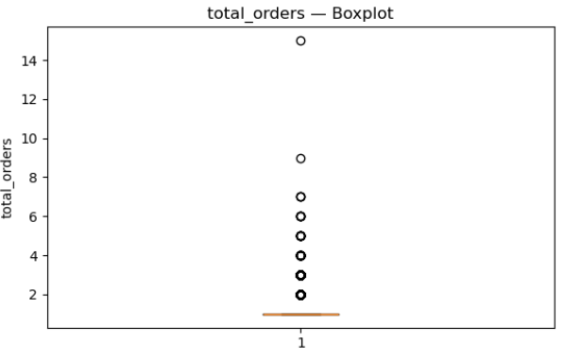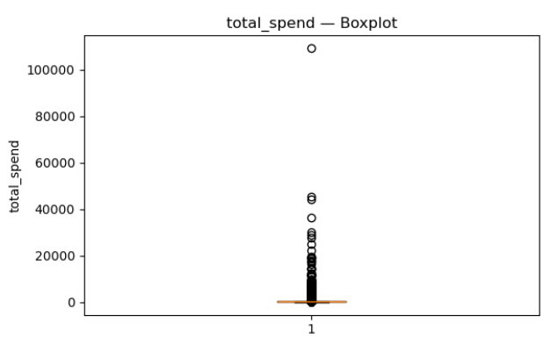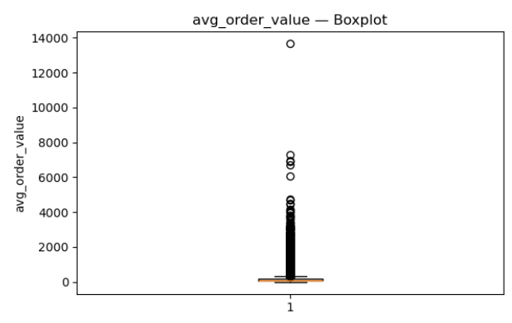

Most variables are complete. The only major gap is review_comment_message (≈59% missing), which is expected because many customers rate without writing a comment; this makes the text data NMAR and may skew topics toward stronger opinions. The remaining gaps are tiny: most_common_category (~1.4%) and single cases in avg_review_score, avg_order_value, and avg_payment_installments (≤0.65%). For modelling, we keep rows and median-impute the few numeric misses, set “Unknown” for the rare missing category (used only descriptively), and proceed. For BERTopic, we use only non-empty comments and note the potential opinion bias in interpretation.
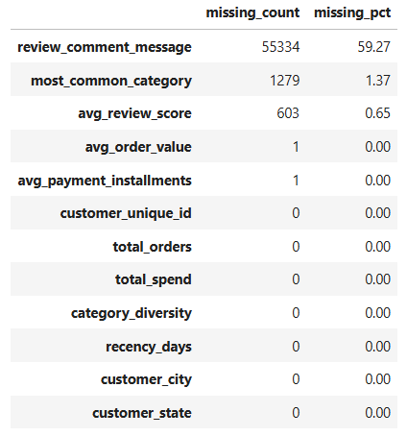
Data cleaning and transformation
Building on the EDA strong right-skew and heavy outliers in total_orders, total_spend, and avg_order_value, plus very small pockets of missing data—we apply three simple, robust steps to prepare the features for clustering.
Imputation
Numeric gaps are rare (≤0.65%) and the distributions are skewed, so we use the median (not the mean) to fill avg_review_score and the single missing values in avg_order_value and avg_payment_installments. Median imputation is resistant to the long right tails seen in §5 and helps keep central tendency stable. For the small categorical gap in most_common_category (~1.4%), we fill “Unknown”. This field is used only for descriptive summaries, not for clustering, so the placeholder prevents row loss without influencing the model. We also create simple imputation flags (e.g., imputed_avg_review_score) to document where replacements occurred. For reviewing text, we do no imputation; BERTopic is run only on non-empty review_comment_message, with the NMAR bias noted.

Winsorisation
To limit the leverage of extremes while keeping all customers, we winsorise the three heavy-tailed variables (total_orders, total_spend, and avg_order_value) at fixed cut-offs (e.g., 25th/75th percentiles). Values below/above those bounds are clipped to the thresholds. This preserves rank order for almost all cases but prevents a few very large observations from pulling K-Means centroids, which would distort distances. For transparency, we keep both versions, appending _winsor to the cleaned fields, and use the winsorised versions for modelling while reporting profiles in original units when interpreting segments.
Standardisation
Finally, we apply z-score standardisation (mean = 0, SD = 1) to the final clustering feature set—total_orders_winsor, total_spend_winsor, avg_order_value_winsor, avg_payment_installments, avg_review_score, category_diversity, and recency_days. Standardising ensures no variable dominates purely due to scale and directly addresses K-Means’ sensitivity to feature magnitudes. We store the scale parameters (means/SDs) so the same transformation can be applied consistently to future data.
The figure below shows the results after data cleaning process, which are well-prepared for data clustering.
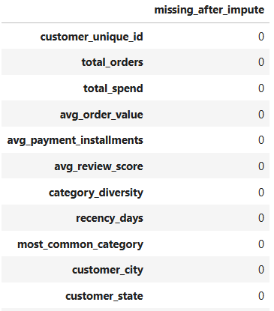
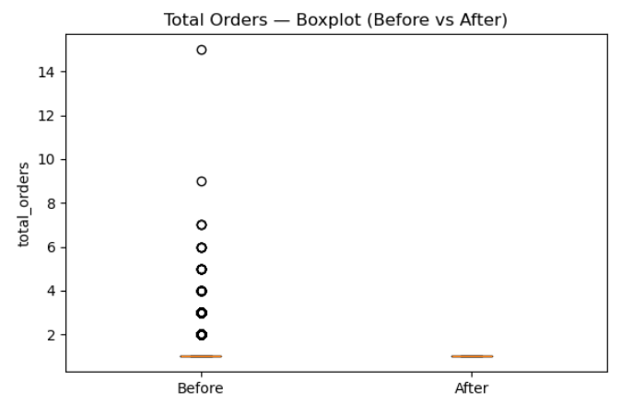
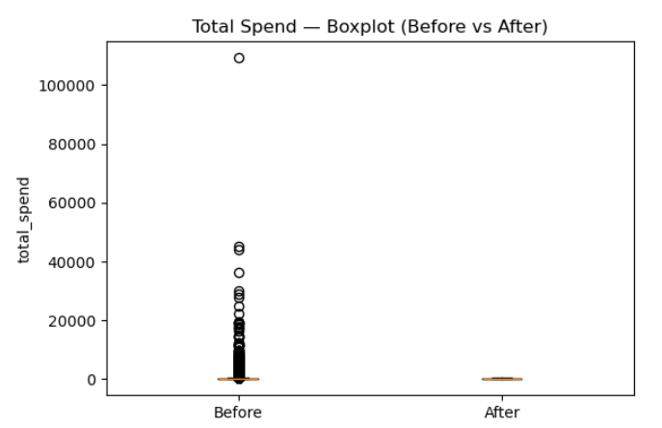
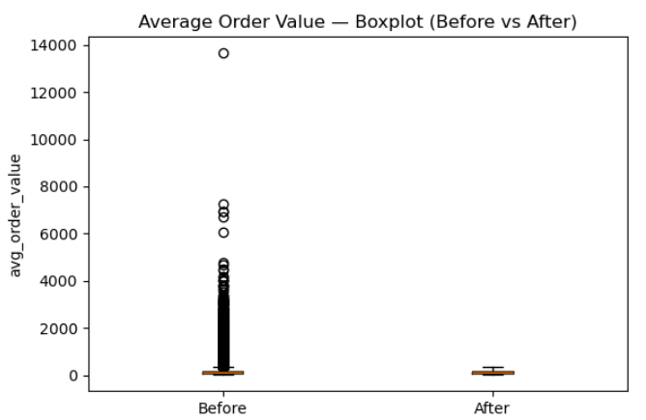

Clustering
Elbow method
Based on EDA and interpretability, we cluster on the standardised features:
total_orders_winsor, total_spend_winsor, avg_order_value_winsor, avg_payment_installments, avg_review_score, category_diversity, recency_days.
K-Means minimises inertia (within-cluster sum of squares, WCSS). As K increases, inertia always goes down, but with diminishing returns. The elbow method plots inertia vs. K and looks for the “knee” where the curve starts to flatten. That point balances compact clusters against model simplicity (not over-splitting the data).
Interpreting the elbow plot above.
- The drop in inertia is very large from K=1 → 2 and still substantial to K=3 and K=4.
- There is a meaningful improvement at K=5 (~255k), but after K=5 the curve flattens: reductions become smaller (e.g., ~255k → ~228k at K=6, then down to ~200k at K=7 and ~157k at K=10).
- This shape indicates an elbow around K=5 (arguably between 4 and 6). Choosing K=5 captures most of the gain in compactness without fragmenting the data into many small clusters.

Model fitting and labelling
We fit K-Means with a fixed seed, and multiple restarts to avoid poor local minima. Each customer receives a cluster label. For interpretation, we profile segments on the original (unscaled) units (e.g., spend in currency, recency in days) before proceeding to statistical validation (ANOVA and Tukey HSD).
Cluster statistical validation
To test whether clusters differ statistically (beyond visual/managerial differences), we apply One-way ANOVA. For each numeric feature, we estimate a one-way ANOVA model with cluster as the factor and report F-statistics and p-values. ANOVA evaluates whether there is a significant difference in means across the clusters (statsmodels ANOVA docs).
Tukey HSD post-hoc. Where ANOVA is significant, we run Tukey’s HSD to identify which cluster pairs differ while controlling family-wise error rate. We report adjusted p-values and confidence intervals for pairwise mean differences (statsmodels pairwise_tukeyhsd).
This statistical layer strengthens the validity of managerial interpretations by confirming (or challenging) whether observed differences in, e.g., spend, frequency, or satisfaction are statistically robust.
Topic Modelling
Cluster selection for topic modelling
After interpreting the five segments, then selecting one target cluster for qualitative enrichment to do the personalized marketing either because it represents a priority persona for growth/retention or because it exhibits pain-points (e.g. lower review scores). by filtering only the selected cluster and then exporting it to the new csv file in order to do the topic modelling
We begin by loading a single column dataframe of review texts and treating that first column as the input corpus (TEXT_COL = df.columns[0]). All entries are cast to strings and collected into a Python list (texts). This keeps the corpus identical to the source table and preserves the original ordering of reviews.
To tailor the vocabulary to Brazilian Portuguese, we load NLTK stopwords and extend them with common colloquial tokens (e.g., “pra”, “pro”, “vc”). We configure a CountVectorizer with these Portuguese stopwords, unigram+bigram features (ngram_range=(1,2)), and a minimum document frequency of five (min_df=5). This vectorizer is later used by BERTopic’s class-based TF-IDF to build topic representations that emphasise consistently used words and short phrases.
For semantic representations, the pipeline uses the SentenceTransformer model "paraphrase-multilingual-MiniLM-L12-v2". This model is multilingual and performs well on Portuguese while remaining fast, which makes it suitable for large review corpora. We then project the high-dimensional embeddings to a compact space with UMAP (n_neighbors=15, n_components=5, min_dist=0.0, metric="cosine", random_state=42). These settings encourage dense neighbourhoods in reduced space and keep the run reproducible. Clustering is performed with HDBSCAN (min_cluster_size=10, metric="euclidean", cluster_selection_method="eom", prediction_data=True), which extracts stable groups without forcing every document into a topic.
With these components in place, we instantiate BERTopic and attach a KeyBERTInspired representation model so that each topic’s top keywords are derived in a way that balances relevance and diversity. We pass in the custom vectorizer, the chosen embedding model, and the UMAP/HDBSCAN objects, and enable probability calculations for later interpretation. Calling fit_transform(texts) produces, for each review, a topic label and a probability vector indicating how strongly the review belongs to its assigned topic.
The code then materialises the main artefacts needed for reporting and later integration:
A topic overview table (get_topic_info) with topic IDs, sizes, and top keywords is exported to CSV, a compact table of representative documents is created by taking the top three exemplar reviews per topic. Document-to-topic assignments are saved as a CSV aligned to the original input order, an interactive bar chart of topic frequencies is rendered to HTML for quick, shareable inspection.
Next, the workflow computes quantitative quality indicators for the discovered topics. It reloads the topic overview, filters out the outlier topic -1, and converts the Representation column (stored as strings in the CSV) back into Python lists. Using the same multilingual transformer model, it embeds the top keywords of each topic and calculates semantic coherence as the average pairwise cosine similarity among those keyword embeddings. In parallel, it computes keyword diversity as the ratio of unique keywords to total keywords across all topics. These two metrics are then written back to disk in a “topics with metrics” CSV and summarised to the console (mean coherence and overall diversity). Together, they provide a simple, model-agnostic check on interpretability (coherence) and redundancy (diversity) without altering the learned topics.
Finally, for visual interpretation, the code generates word clouds for topics 0–9. It reloads the topic overview, removes topic -1, concatenates each topic’s representative keywords into a short text, and renders a word cloud image per topic. The images are displayed inline and saved to a dedicated folder so they can be referenced in the report.

Appendix D: Business Proposal
Business Proposal: Analyzing Customer Insights through Behavioral Clustering and BERTopic Analysis: A Case Study of Olist E-commerce
Aims and Objectives
This project is designed to help Olist, a Brazilian e-commerce platform, better understand and serve its customers. The study has two core objectives:
- To segment Olist customers based on behaviors using unsupervised machine learning (K-Means clustering).
- To analyze customer reviews using natural language processing (NLP), specifically BERTopic, to know key satisfaction and pain points.
The aim is to gain insights that can inform marketing strategies and customer service improvements designed for different customer segments.
Research Questions
- What are the main customer segments in Olist based on customer behavior?
- What themes frequently appear in customer reviews, and how do these vary between different segments?
Literature Overview
The rapid growth of e-commerce globally has initiated new challenges and demands in data analysis. According to Chen, Zhao, and Wang (2021), E-commerce platforms are increasingly reliant on large-scale data-driven decision making, as traditional strategies are insufficient for modern digital consumer behavior. Academic studies confirm that customer data when segmented properly can reveal underlying patterns in buying behavior, preferences, and pain points (Wong, Tong, & Haw, 2024).
Brazil, as one of the fastest-growing digital commerce markets in Latin America. Research by Mahdjoub (2024) highlights the challenge of building scalable analytics pipelines for platforms like Olist, noting that customer satisfaction models must include both structured (e.g., transaction history) and unstructured data (e.g. reviews).
In this context, customer segmentation has been a foundation of marketing strategy for decades. Traditionally, segmentation uses Recency, Frequency, and Monetary (RFM) value metrics, which have been proven effective for identifying customer value and loyalty (Wong, Tong, & Haw, 2024). K-Means clustering, a commonly used unsupervised machine learning algorithm, is particularly well-suited to this type of segmentation because it efficiently groups data points with similar characteristics (Jain, 2010).
For example, Kadir and Achyar (2019) used K-Means to segment customers of an Indonesian e-retailer and successfully identified three primary customer types, enabling tailored engagement strategies. In another case, Naboulsi (2020) applied K-Means to Olist’s own datasets and found that customer clusters showed distinct behaviors that could be exploited for better business performance.
In parallel, text analytics has emerged as a powerful complement to quantitative segmentation. BERTopic, an advanced topic modeling method that builds on transformer-based language models like BERT, has shown effectiveness in extracting coherent and meaningful topics from review text (Grootendorst, 2022). Unlike earlier models like Latent Dirichlet Allocation (LDA), BERTopic accounts for word context and performs well with short texts like e-commerce reviews.
Maarif (2022) demonstrated that combining topic modeling and sentiment analysis provides a structured and efficient way to summarize large volumes of e-commerce reviews. This approach helps to uncover key product-related themes and shows how customers feel about each, offering valuable input for product evaluation and business strategy. Mahdjoub (2024) applied machine learning models to predict customer satisfaction in Olist’s dataset and emphasized the importance of combining structured and unstructured data for a holistic view of customer experience.
These studies support the use of both K-Means clustering and BERTopic in e-commerce analytics. To address the gap in previous studies, this project uses both techniques to analyze the Olist e-commerce dataset, integrating customer location to gain deeper insights. By combining this with topic modeling and sentiment analysis, we aim to better understand customer reviews and support improved marketing strategies for the future.
Methodology
Data Sources
The data used in this project comes from the publicly available Olist e-commerce dataset (Olist & André, 2018). This dataset contains order transactions, customer demographics, product details and written customer reviews.
We will explore and merge these datasets to build a integrated view of customer behavior and feedback. The dataset enables us to:
- Understand purchasing behavior in the different location in Brazil (order volume, value, delivery time and etc.)
- Analyze customer satisfaction through star ratings and review text
To Know Customer Behavior and Experience
Clustering with K-Means
K-Means clustering will be used to group customers. The Elbow Method will guide the selection of the optimal number of clusters (K). Each cluster will be labeled according to its defining features and visualized. These clusters will be profiled to assess their value to the business.
Statistical Validation: ANOVA and Tukey’s Test
To validate the differences between customer clusters, we will use two-way ANOVA (Analysis of Variance) to assess whether the means of key numeric features (e.g., order value, review scores, wait time) are statistically different across clusters. If ANOVA identifies significant differences (p < 0.05), we will conduct Tukey’s Honest Significant Difference (HSD) post-hoc test to determine which specific cluster pairs are significantly different.
To Know the insight from Topic Modelling from the reviews
Topic Modeling with BERTopic
Text preprocessing will clean review data by removing punctuation, converting to lowercase, and filtering stopwords. If needed, review text will be translated from Portuguese to English using automated multilingual BERT models.
BERTopic will be used to:
- Embed reviews using BERT transformers
- Reduce dimensionality with UMAP
- Cluster review embeddings using HDBSCAN
- Extract topics with class-based TF-IDF
Sentiment polarity (positive/neutral/negative) will be added using rule-based or machine learning sentiment models.
Topics and sentiment scores will be grouped by customer state to identify geographic variations in customer satisfaction.
Data Analysis Plan
- Perform exploratory data analysis to understand distributions and correlations.
- Run K-Means clustering and identify optimal K.
- Use two-way ANOVA to test for statistical differences in numerical variables (e.g. review scores, order values) among clusters.
- Apply Tukey's HSD post-hoc test to identify which specific clusters differ significantly.
- Generate data visualization for cluster analysis and label cluster name by the results.
- Apply BERTopic to review comments and extract top 5 - 10 topics.
- Assess topic distribution and sentiment by cluster.
- Integrate findings: link behavioral segments to review sentiment where applicable.
Expected Outcomes
This project is expected to deliver the following outcomes:
- Clear customer segments with descriptive profiles for each group.
- Statistical validation of segment differences using ANOVA and Tukey’s test.
- A set of topics from customer reviews, grouped by segment and sentiment (positive, negative, neutral).
- Insights into regional pain points, helping identify improvement areas in product offering, or customer service.
Business Implementation
- Targeted marketing: Personalized promotions or loyalty programs can be designed for each customer group based on their behavior and preferences.
- Customer support and retention: Frequently mentioned complaints can inform proactive customer support strategies, reducing churn.
- Product development: Insights from review topics can guide product improvements or new offers aligned with customer expectations.
- Strategic planning: Executives can use these customer profiles and sentimental insights to plan region-specific business initiatives.
Ethical Considerations
This project is grounded in ethical research practices to ensure data protection, responsible AI use, and transparency throughout the analytical process.
All data used is part of the publicly available Olist dataset, which is anonymized and contains no personally identifiable information. This confirms compliance with data privacy standards and reduces the risk of violating any individual's privacy.
The project is conducted under the CC BY-NC-SA 4.0, meaning all findings or developed work will be shared openly for academic use, while not for commercial purposes. This supports the commitment to open knowledge and collaboration.
Furthermore, the analysis will avoid any form of algorithmic bias or discriminatory profiling. Customers will be grouped and interpreted solely based on behavior and sentiment, not on protected or sensitive characteristics. The ethical interpretation of data is central to this project and aligns with the University of Exeter's ethical standards for student research.
References
Chen, Y., Zhao, Q., & Wang, L. (2021). Data-driven decision making in e-commerce: A review of customer analytics approaches. Electronic Commerce Research and Applications, 47, 101038. https://doi.org/10.1016/j.elerap.2021.101038
Grootendorst, M. (2022). BERTopic: Neural topic modeling with class-based TF-IDF. arXiv preprint. https://doi.org/10.48550/arXiv.2203.05794
Jain, A. K. (2010). Data clustering: 50 years beyond K-means. Pattern Recognition Letters, 31(8), 651-666. https://doi.org/10.1016/j.patrec.2009.09.011
Kadir, M. A., & Achyar, M. (2019). Customer segmentation on online retail using RFM analysis: Big data case of Bukku.id. ResearchGate. https://www.researchgate.net/publication/335863850
Maarif, M. R. (2022). Summarizing online customer review using topic modeling and sentiment analysis. JISKA (Jurnal Informatika Sunan Kalijaga), 7(3), 177–191. https://doi.org/10.14421/jiska.2022.073-07
Mahdjoub, M. B. (2024). Enhancing customer satisfaction using machine learning. Brazilian Journal of Technology, 7(4), 1–20. https://doi.org/10.38152/bjtv7n4-011
Naboulsi, A. (2020). Data analysis and optimal customer segmentation for Olist. Medium. https://medium.com/@ayman.naboulsi
Olist, and André Sionek. (2018). Brazilian E-Commerce Public Dataset by Olist [Data set]. Kaggle. https://doi.org/10.34740/KAGGLE/DSV/195341
Wong, C.G., Tong, G.K., & Haw, S.C. (2024). Exploring customer segmentation in e-commerce using RFM analysis with clustering techniques. Journal of Telecommunications and the Digital Economy, 12(3), 23-38. Grootendorst, M. (2022). BERTopic: Neural topic modeling with class-based TF-IDF. arXiv preprint. https://doi.org/10.48550/arXiv.2203.05794

